**SPRING DATA JPA**

**MANDATORY HANDS-ON QUESTIONS**

**Hands on 1**

**Spring Data JPA - Quick Example**   
  
**Software Pre-requisites**

* MySQL Server 8.0
* MySQL Workbench 8
* Eclipse IDE for Enterprise Java Developers 2019-03 R
* Maven 3.6.2

**Create a Eclipse Project using Spring Initializr**

* Go to <https://start.spring.io/>
* Change Group as “com.cognizant”
* Change Artifact Id as “orm-learn”
* In Options > Description enter "Demo project for Spring Data JPA and Hibernate"
* Click on menu and select "Spring Boot DevTools", "Spring Data JPA" and "MySQL Driver"
* Click Generate and download the project as zip
* Extract the zip in root folder to Eclipse Workspace
* Import the project in Eclipse "File > Import > Maven > Existing Maven Projects > Click Browse and select extracted folder > Finish"
* Create a new schema "ormlearn" in MySQL database. Execute the following commands to open MySQL client and create schema.

Answer and Output: CODE:

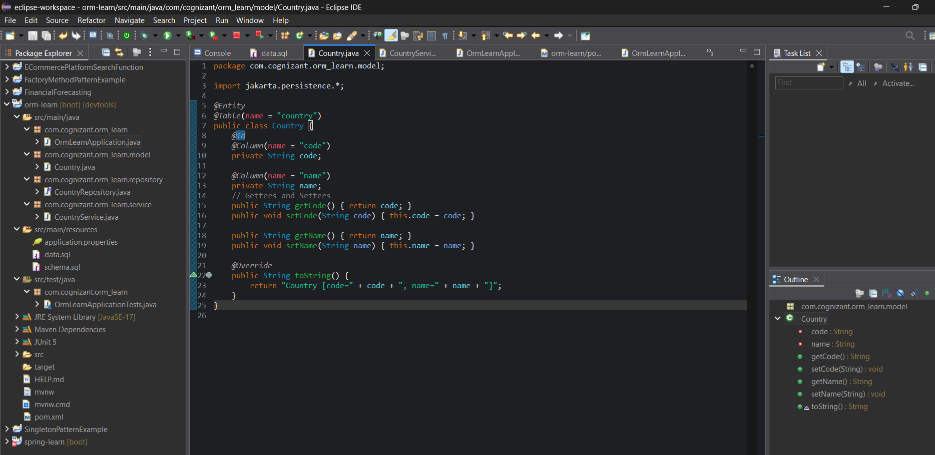

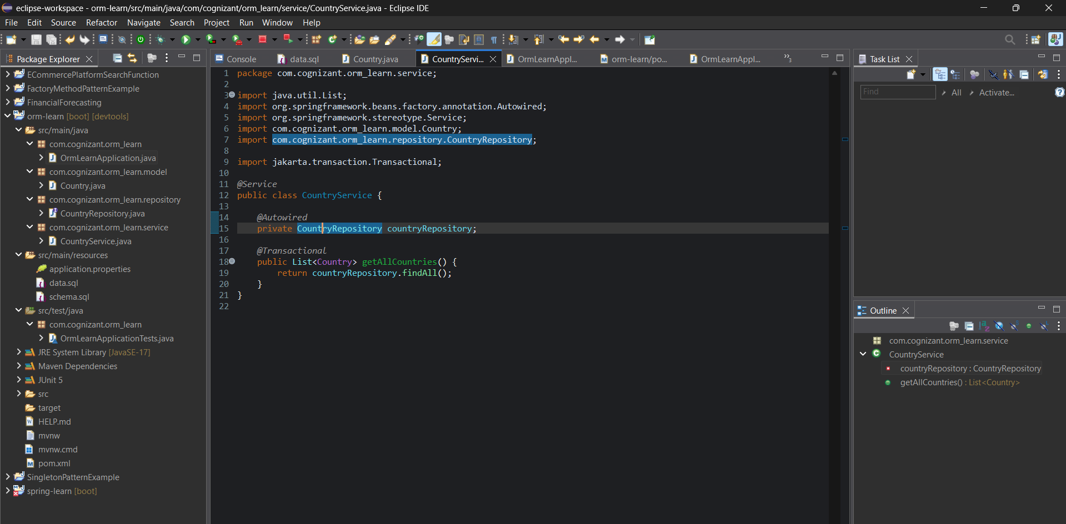

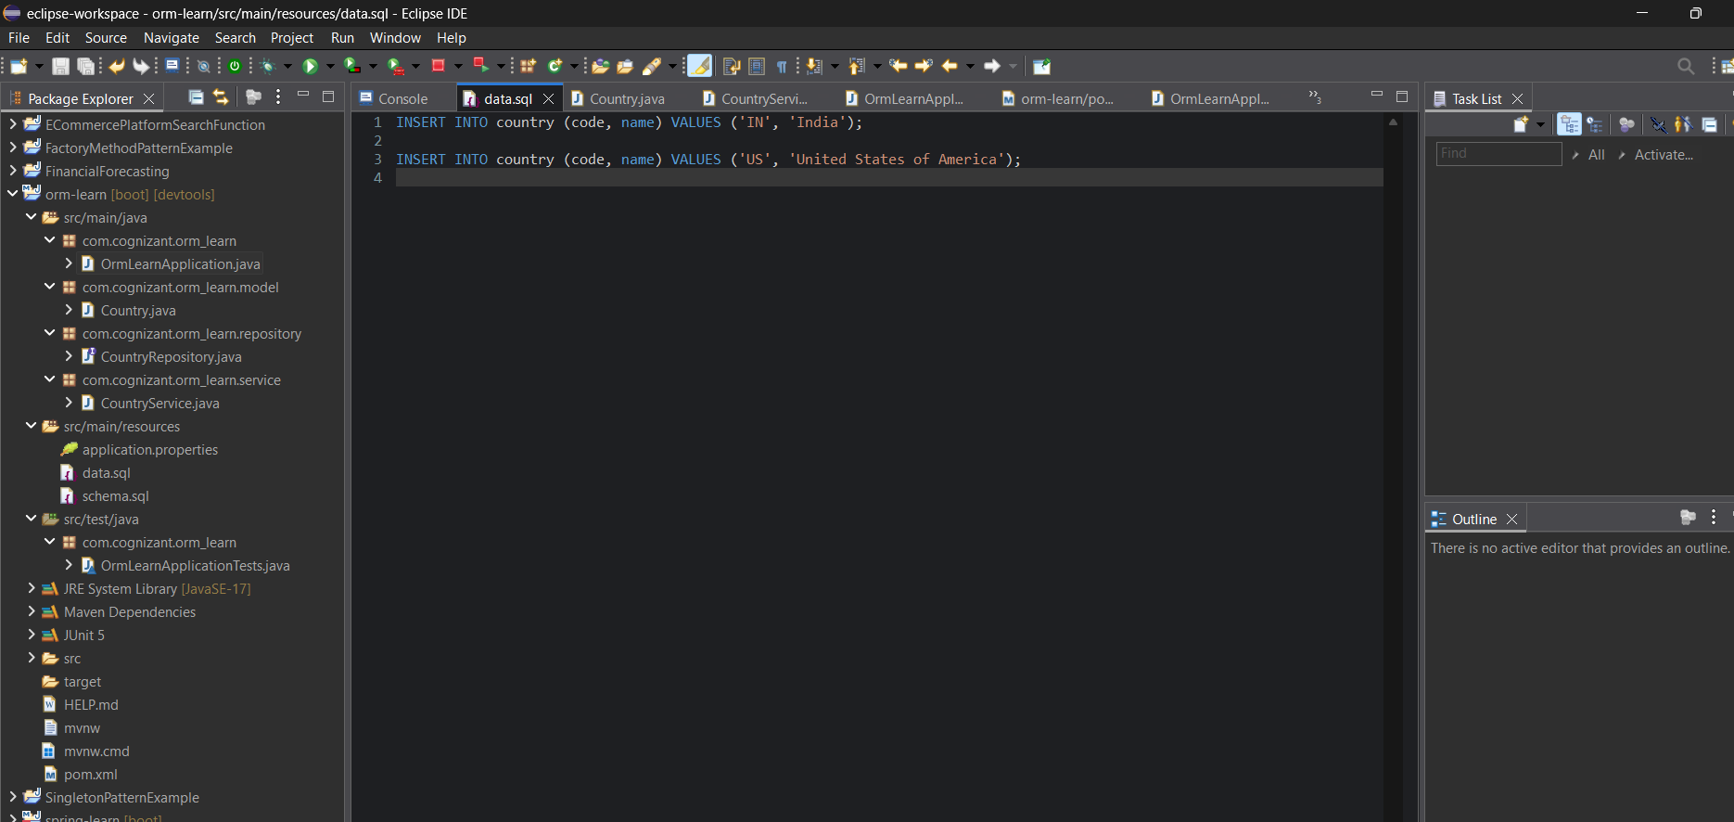

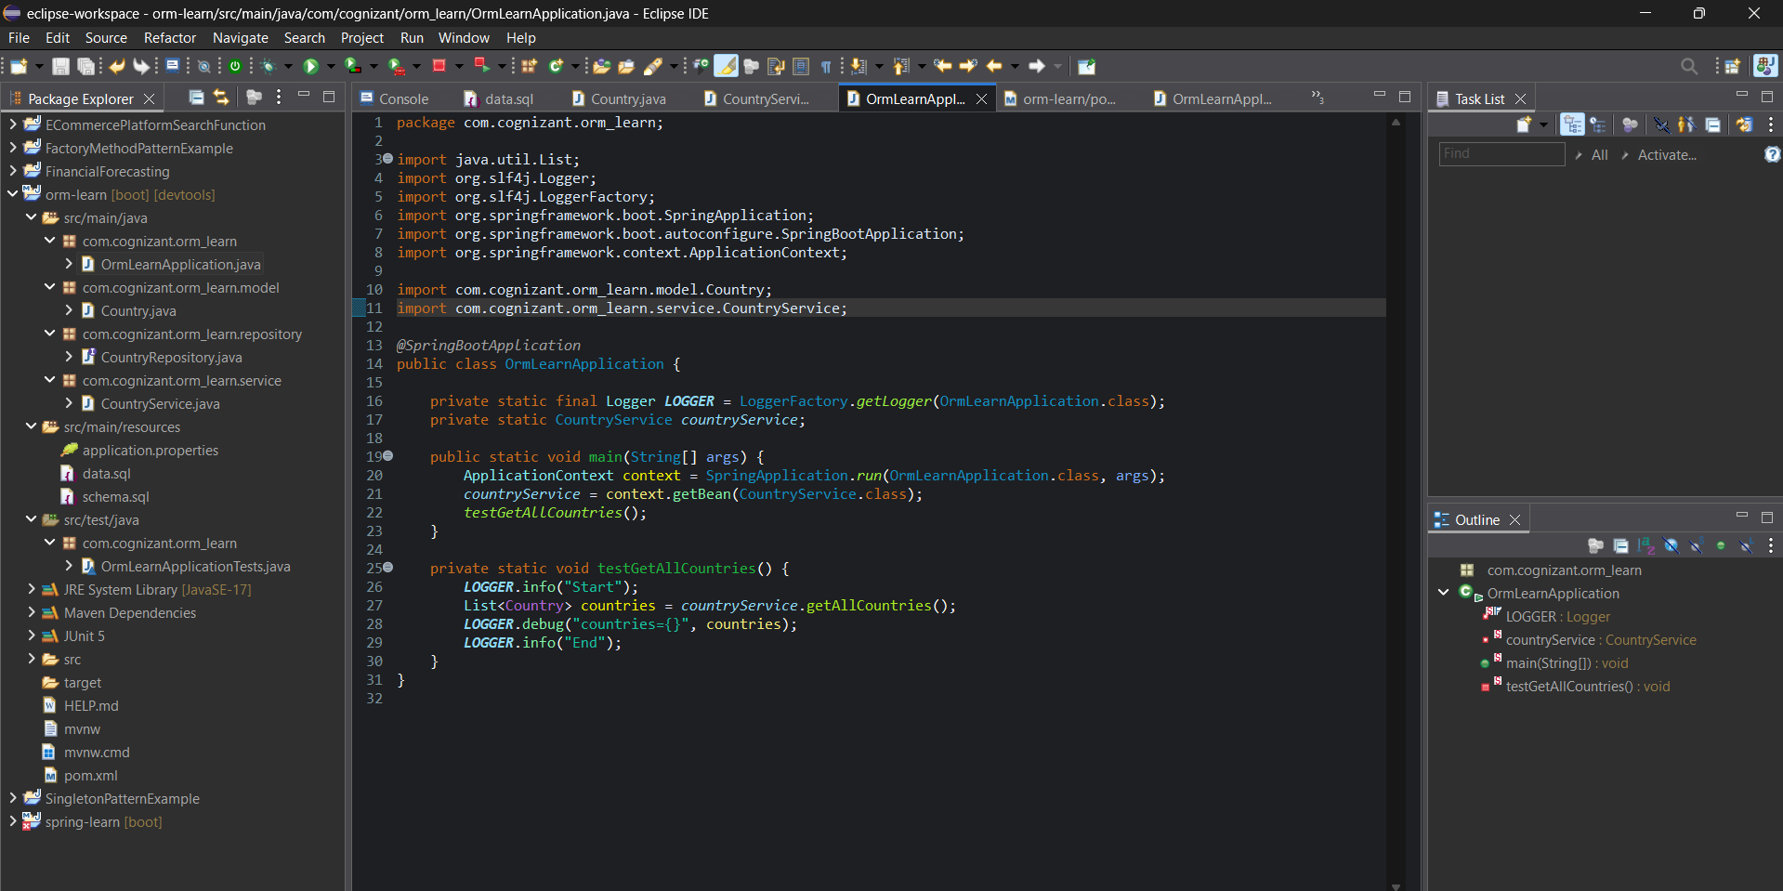

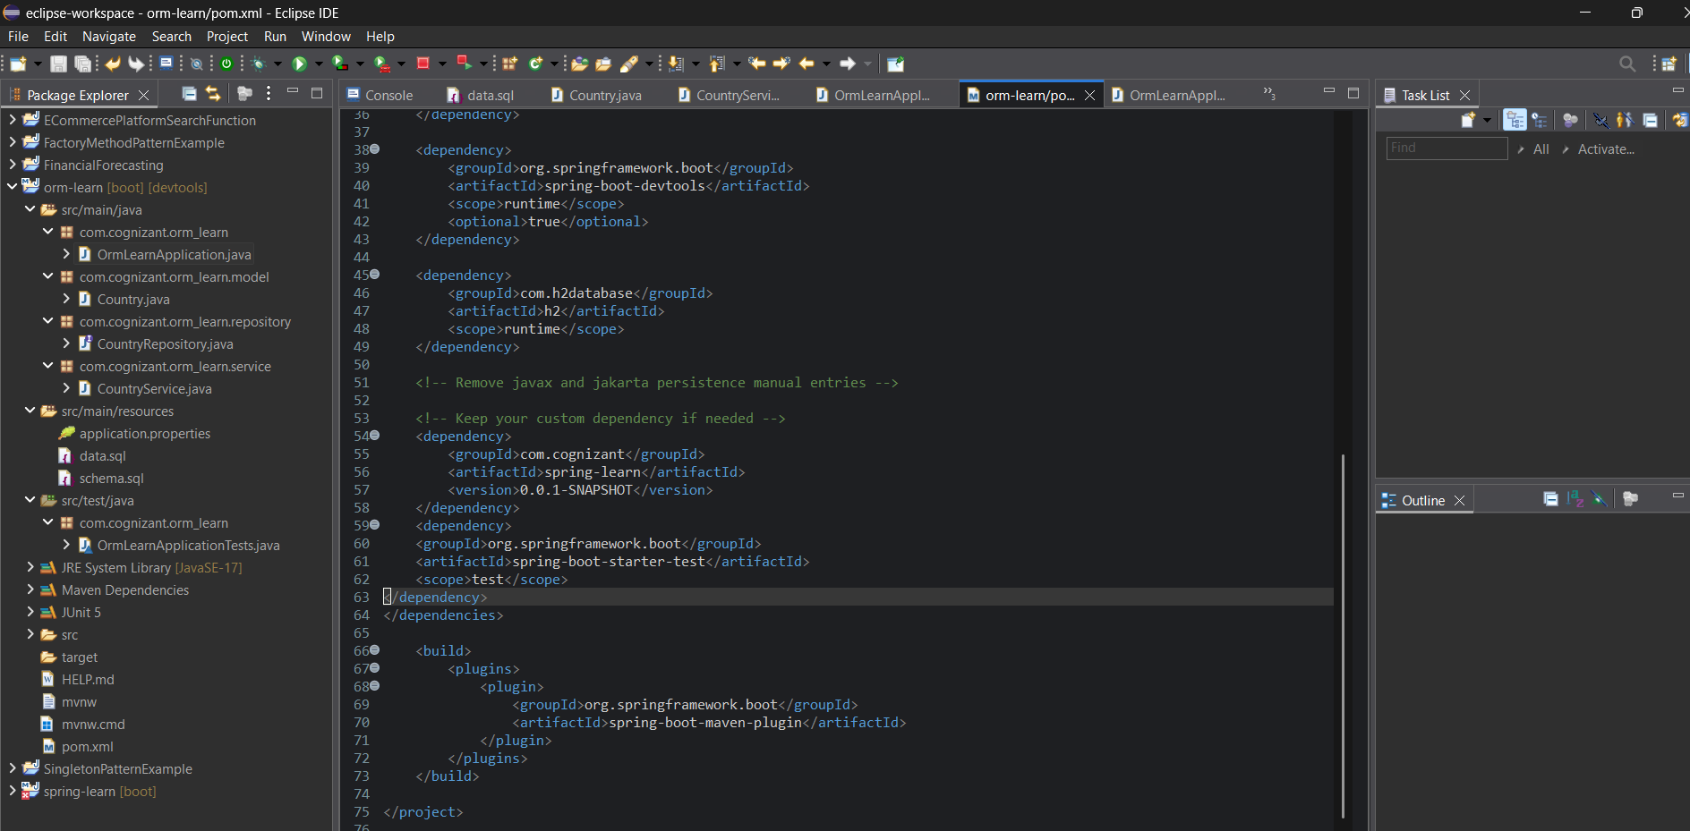

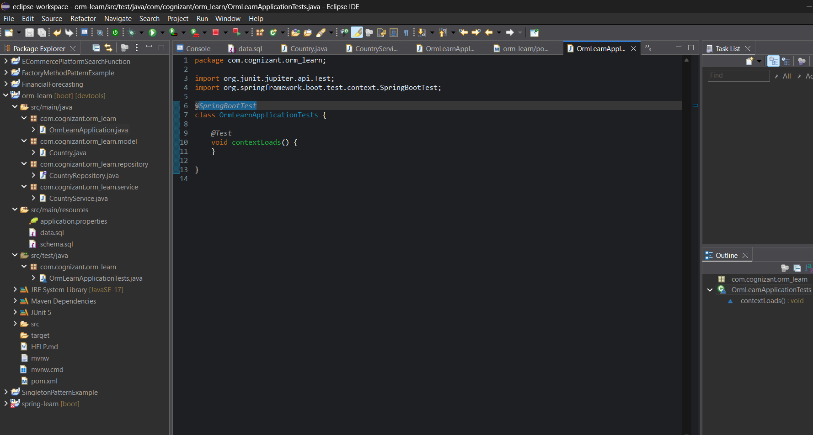

**OUTPUT:**

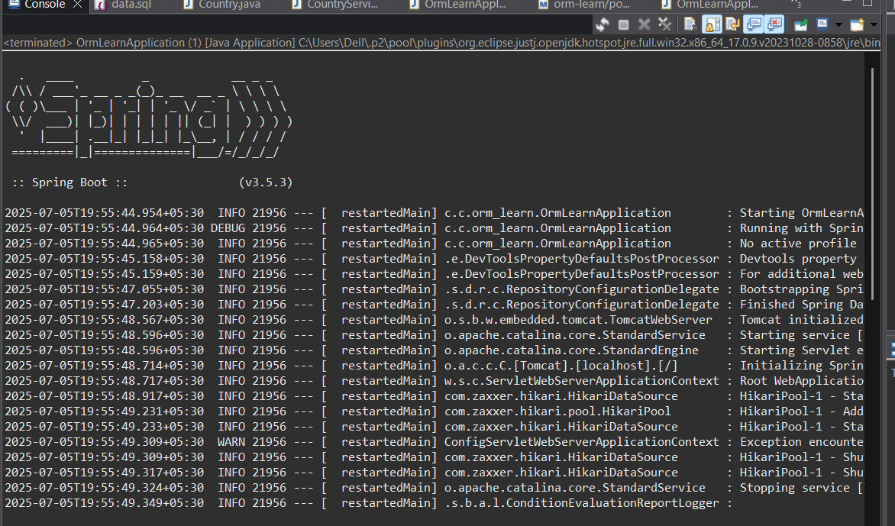

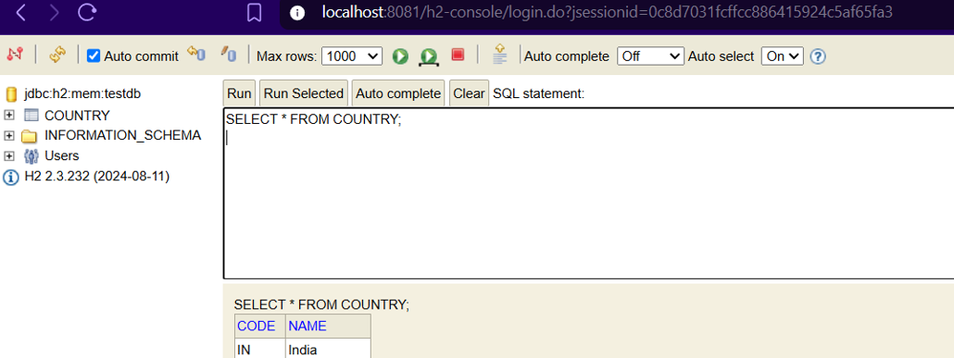

**Question 2**

**Hands on 4**

**Difference between JPA, Hibernate and Spring Data JPA**   
  
Java Persistence API (JPA)

* JSR 338 Specification for persisting, reading and managing data from Java objects
* Does not contain concrete implementation of the specification
* Hibernate is one of the implementation of JPA

Hibernate

* ORM Tool that implements JPA

Spring Data JPA

* Does not have JPA implementation, but reduces boiler plate code
* This is another level of abstraction over JPA implementation provider like Hibernate
* Manages transactions

Answer and Output: The explanation of these topics are done through code below.

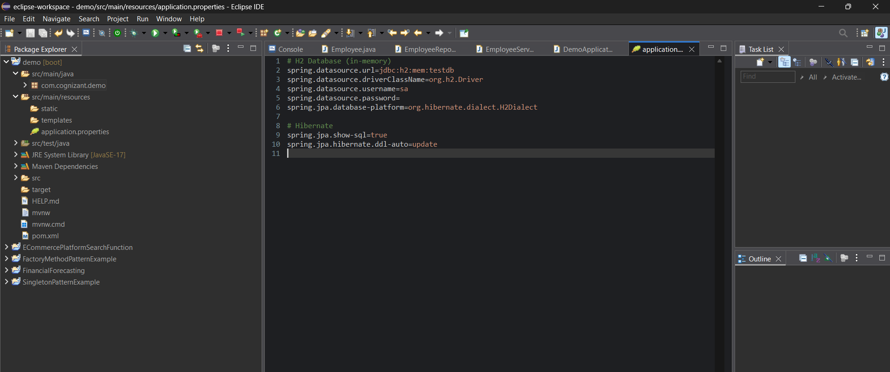

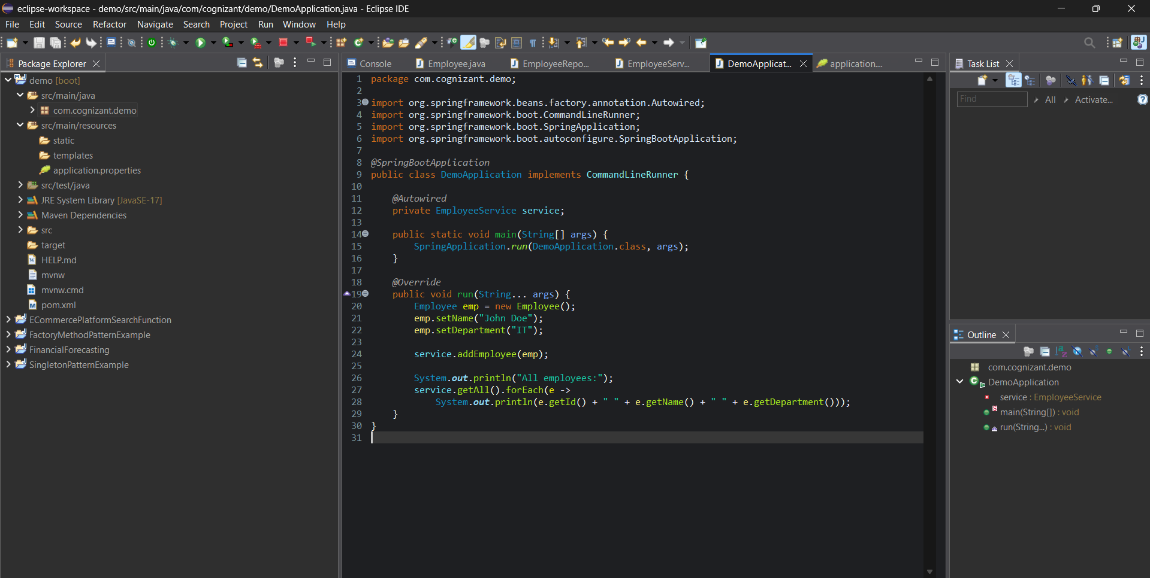

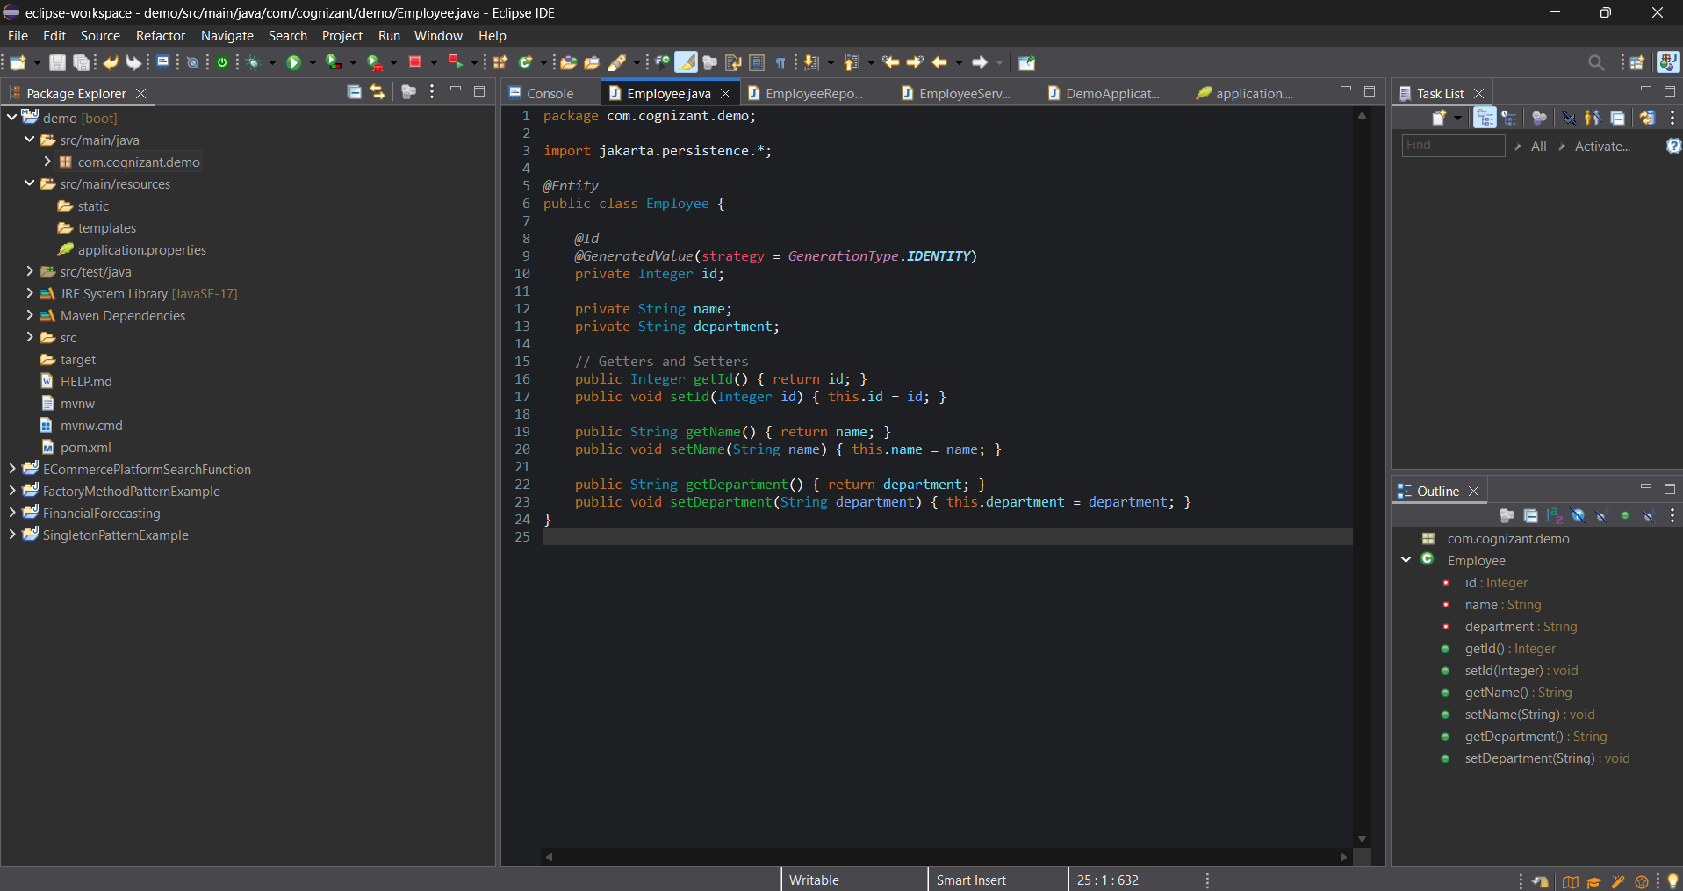

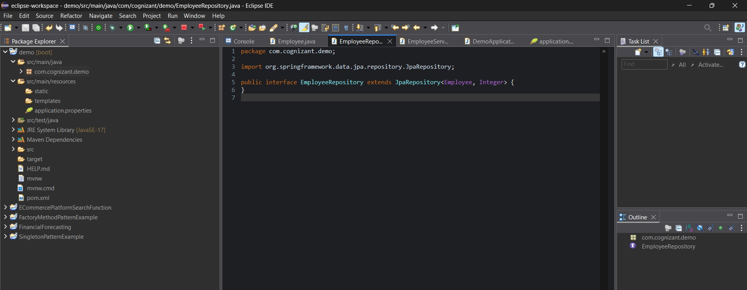

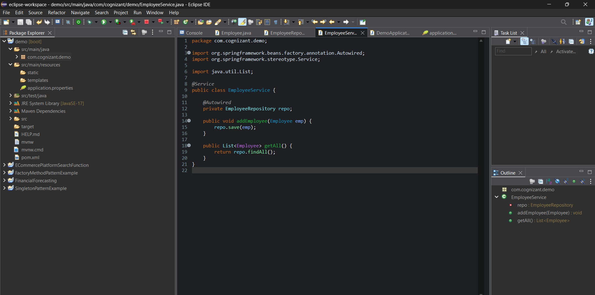

**OUTPUT:**

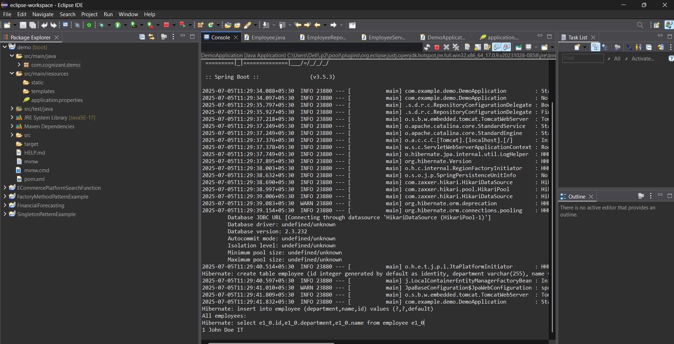

**ADDITIONAL HANDS-ON QUESTIONS**

**Question 1**

**Hands on 6**

**Find a country based on country code** 

* Create new exception class CountryNotFoundException in com.cognizant.spring-learn.service.exception
* Create new method findCountryByCode() in CountryService with @Transactional annotation
* In findCountryByCode() method, perform the following steps:
  + Method signature

@Transactional

public Country findCountryByCode(String countryCode) throws CountryNotFoundException

* Get the country based on findById() built in method

Optional<Country> result = countryRepository.findById(countryCode);

* From the result, check if a country is found. If not found, throw CountryNotFoundException

if (!result.isPresent())

* Use get() method to return the country fetched.

Country country = result.get();

* Include new test method in OrmLearnApplication to find a country based on country code and compare the country name to check if it is valid.

    private static void getAllCountriesTest() {

        LOGGER.info("Start");

        Country country = countryService.findCountryByCode("IN");

  LOGGER.debug("Country:{}", country);

        LOGGER.info("End");

    }

* Invoke the above method in main() method and test it.

Answer and output:

CODE:

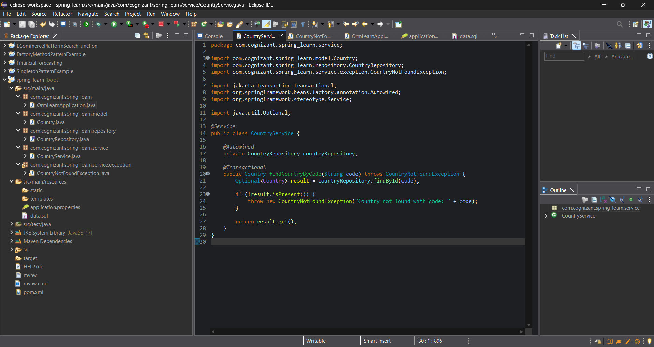

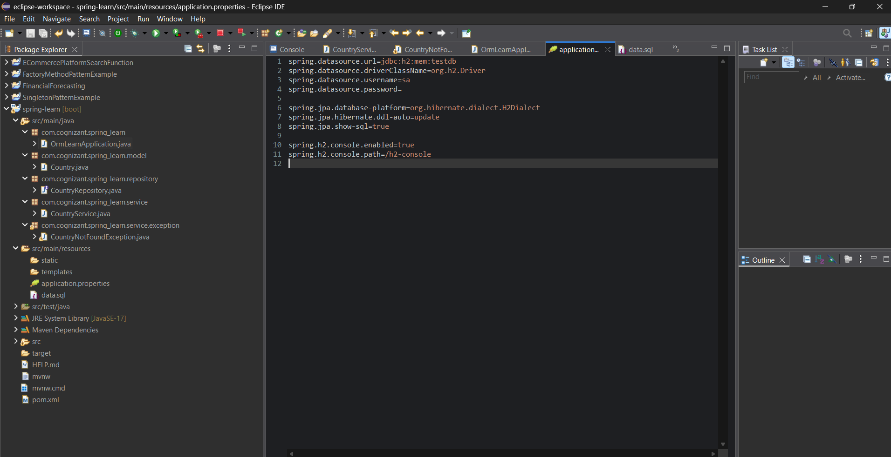

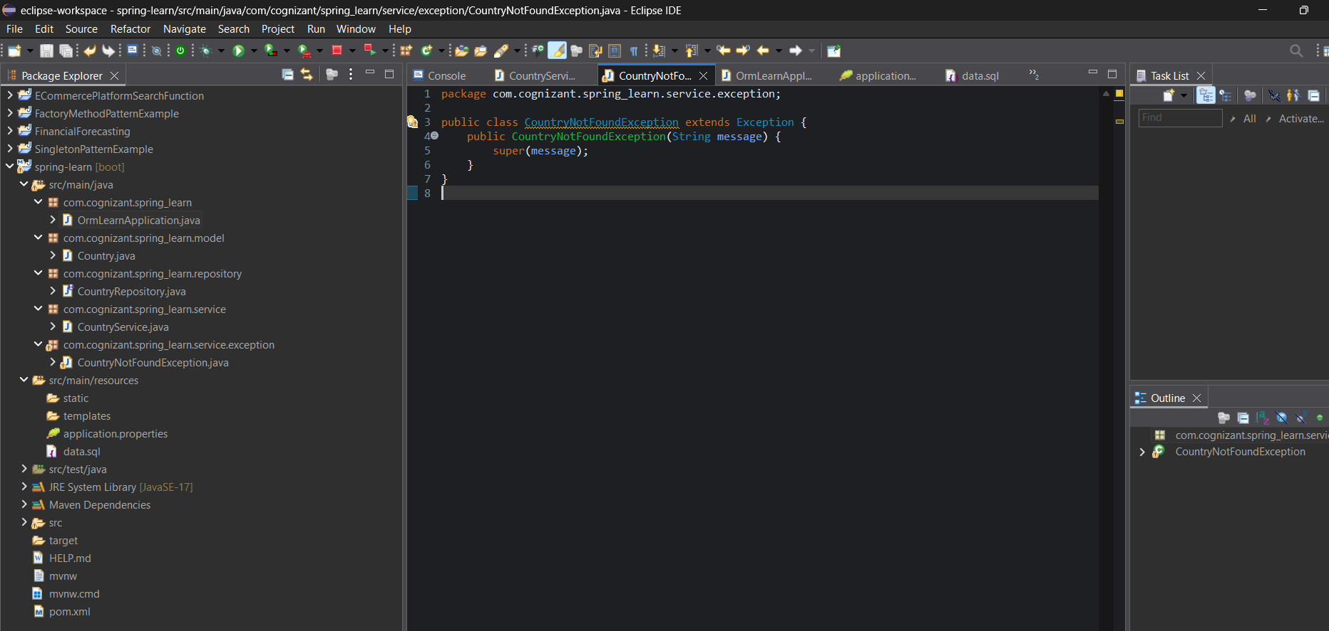

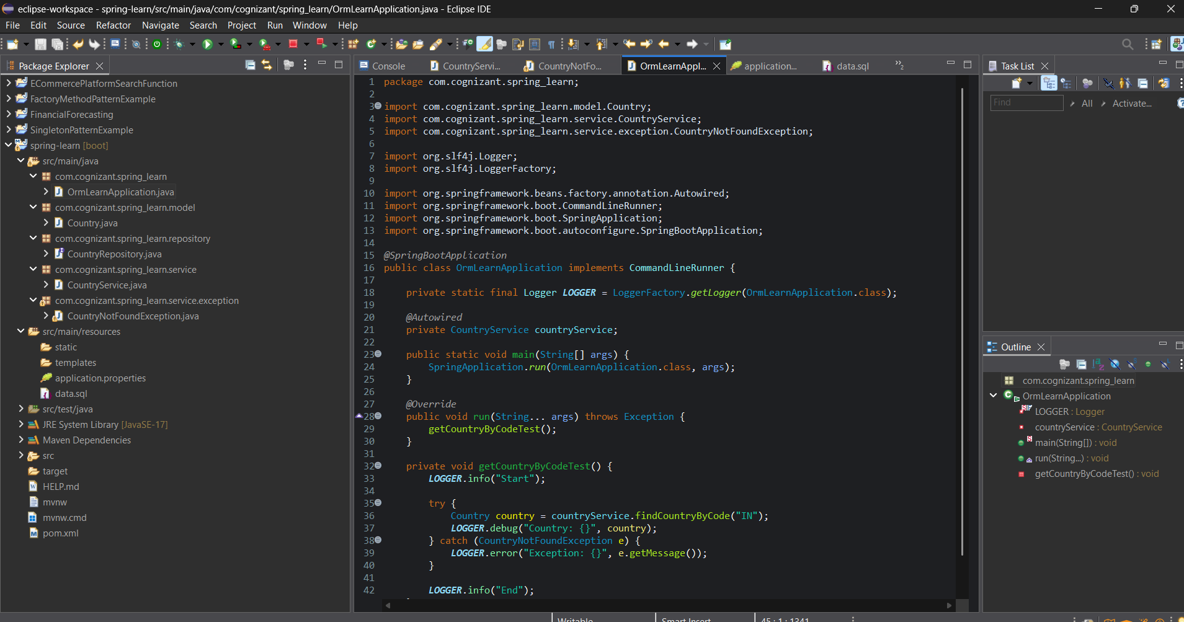

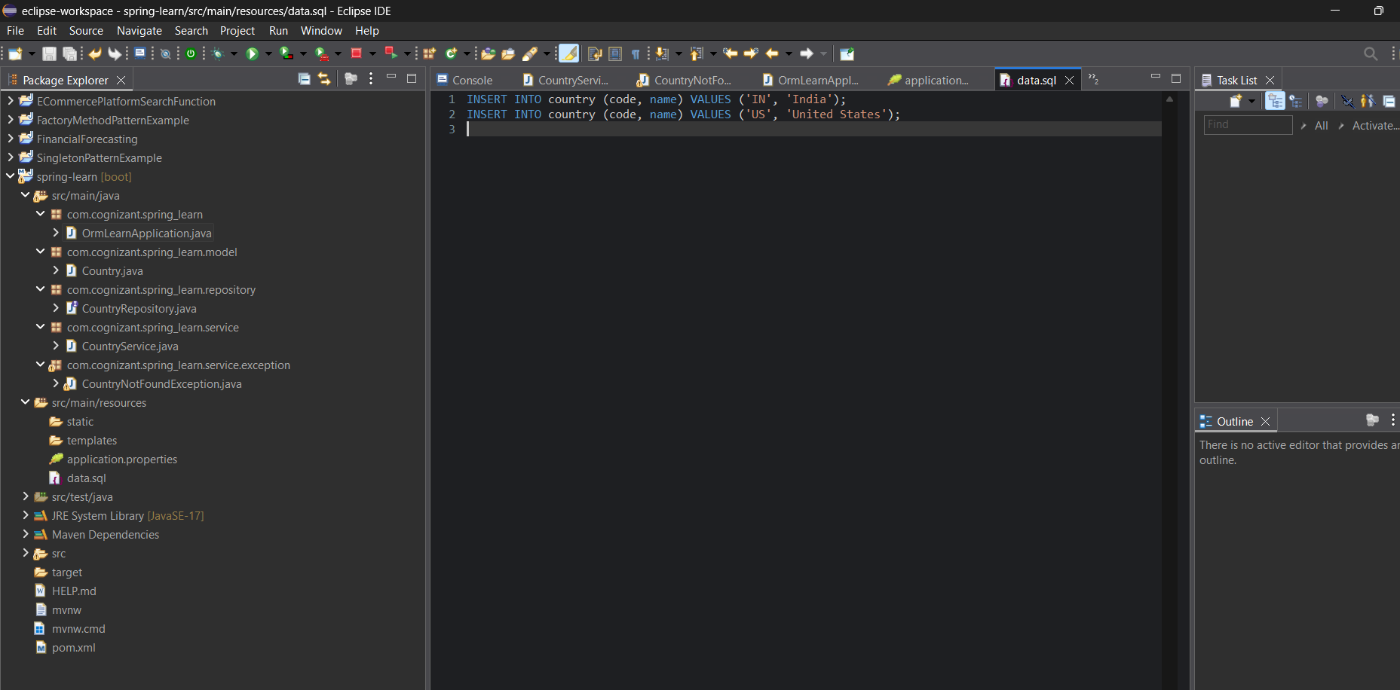

**OUTPUT:**

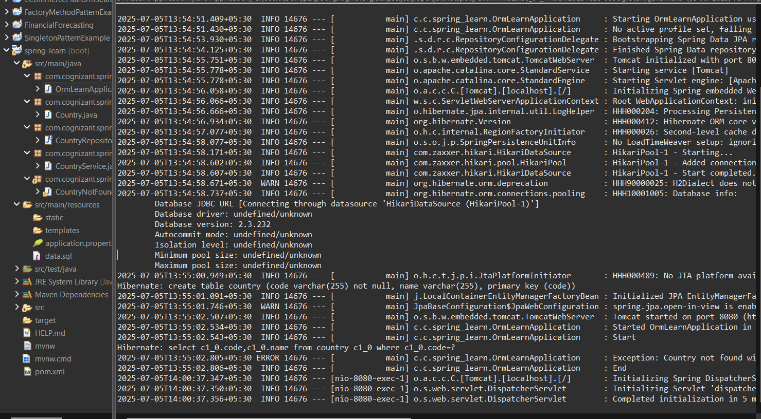

|  |
| --- |
| Hibernate: create table country (code varchar(255) not null, name varchar(255), primary key (code))  Hibernate: insert into country (code, name) values (IN, India)  Hibernate: insert into country (code, name) values (US, United States) |

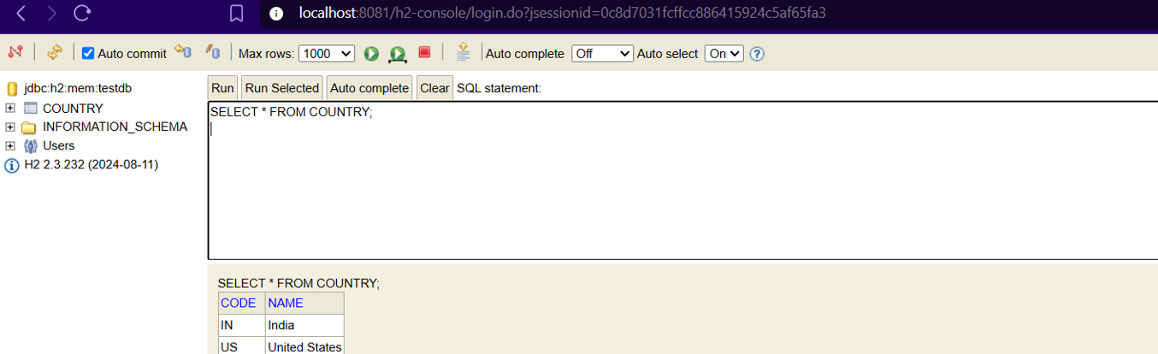

**Question 2**

**Hands on 7**

**Add a new country** 

* Create new method in CountryService.

@Transactional

public void addCountry(Country country)

* Invoke save() method of repository to get the country added.

countryRepository.save(country)

* Include new testAddCountry() method in OrmLearnApplication. Perform steps below:
  + Create new instance of country with a new code and name
  + Call countryService.addCountry() passing the country created in the previous step.
  + Invoke countryService.findCountryByCode() passing the same code used when adding a new country
  + Check in the database if the country is added

Answer and Output:

CODE:

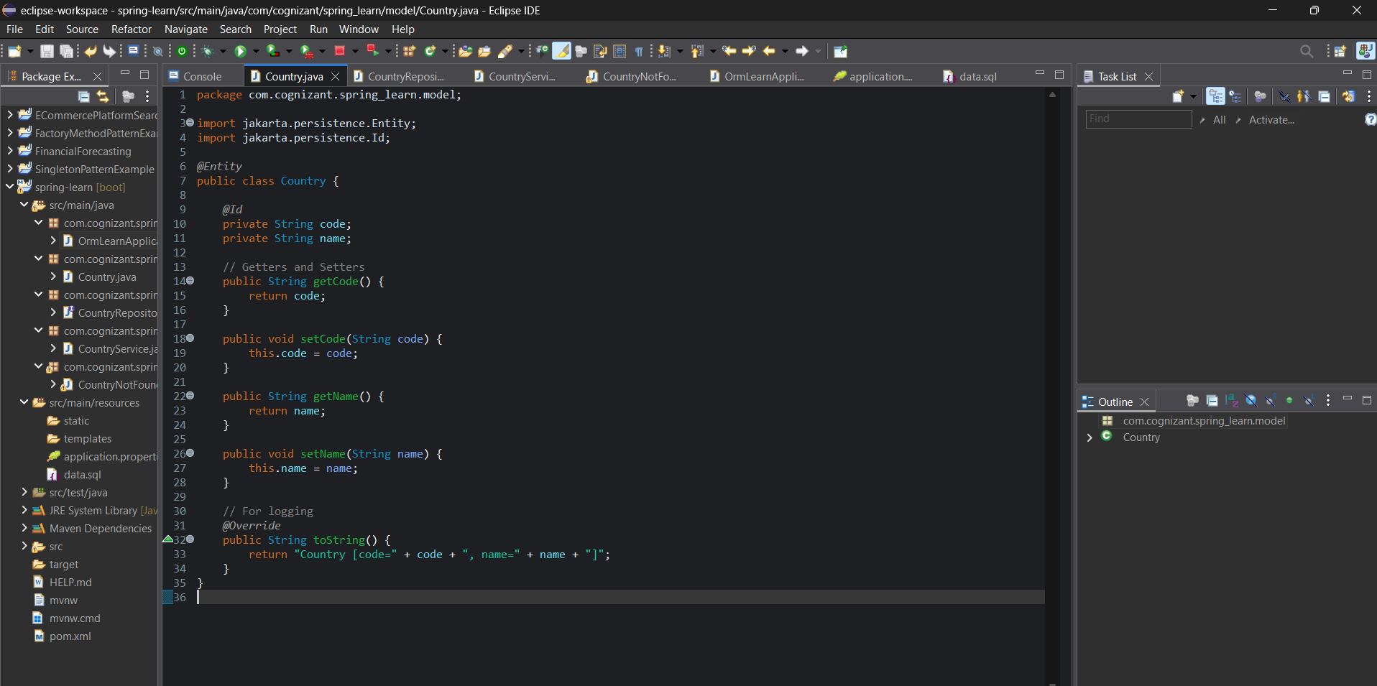

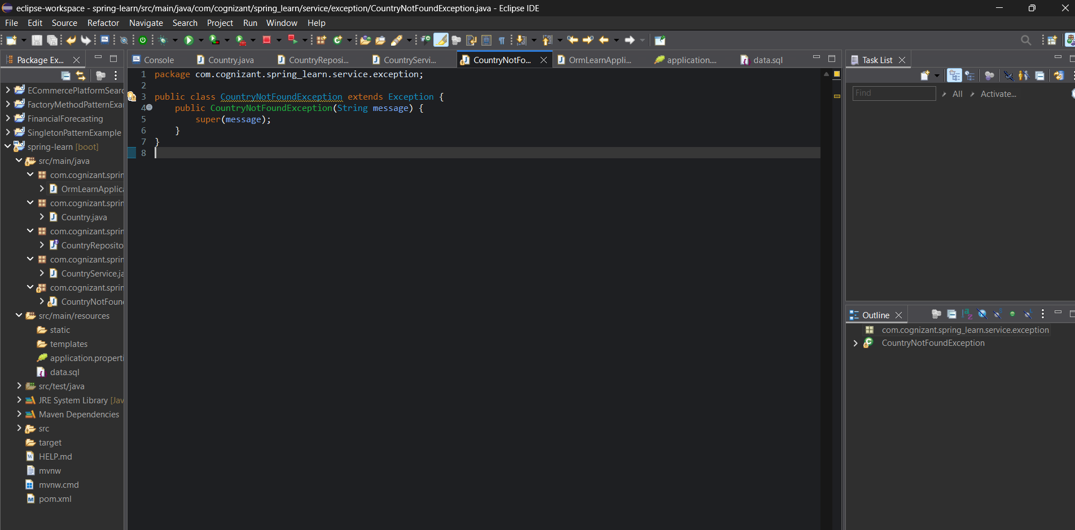

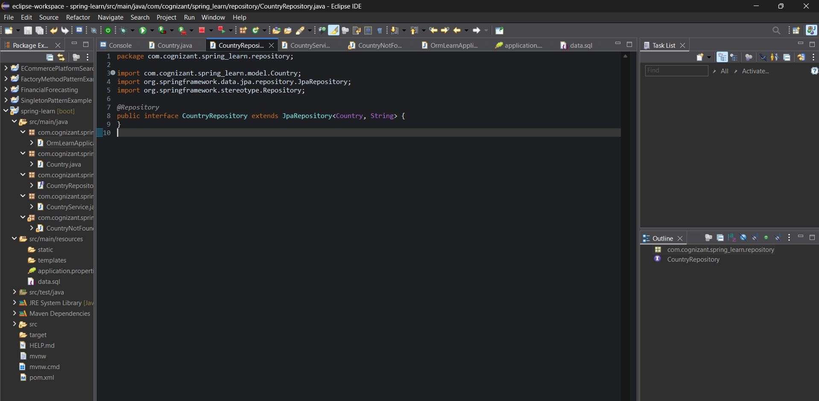

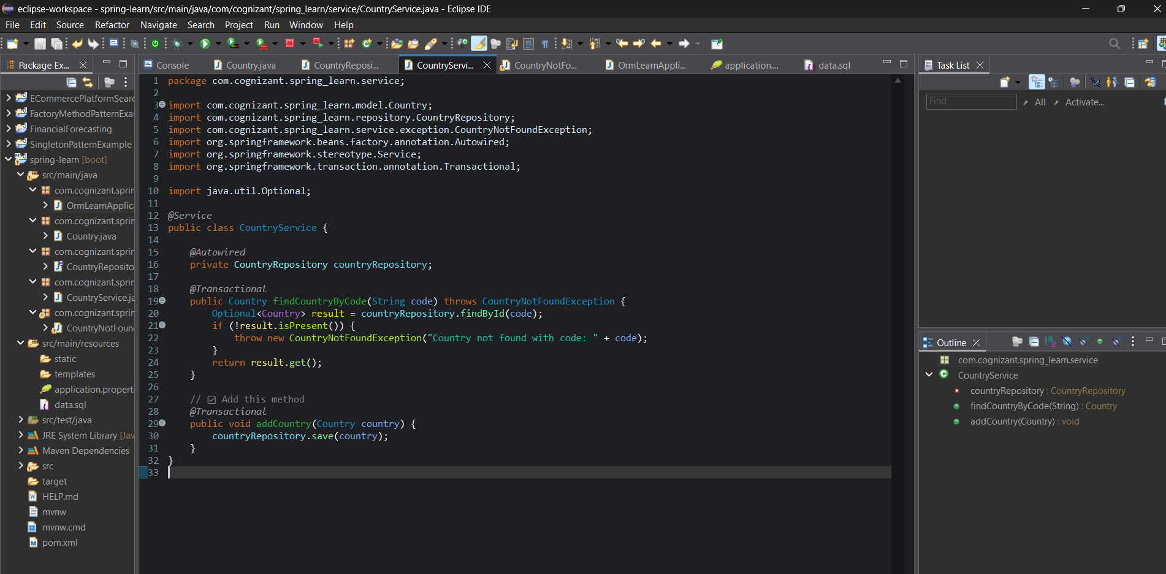

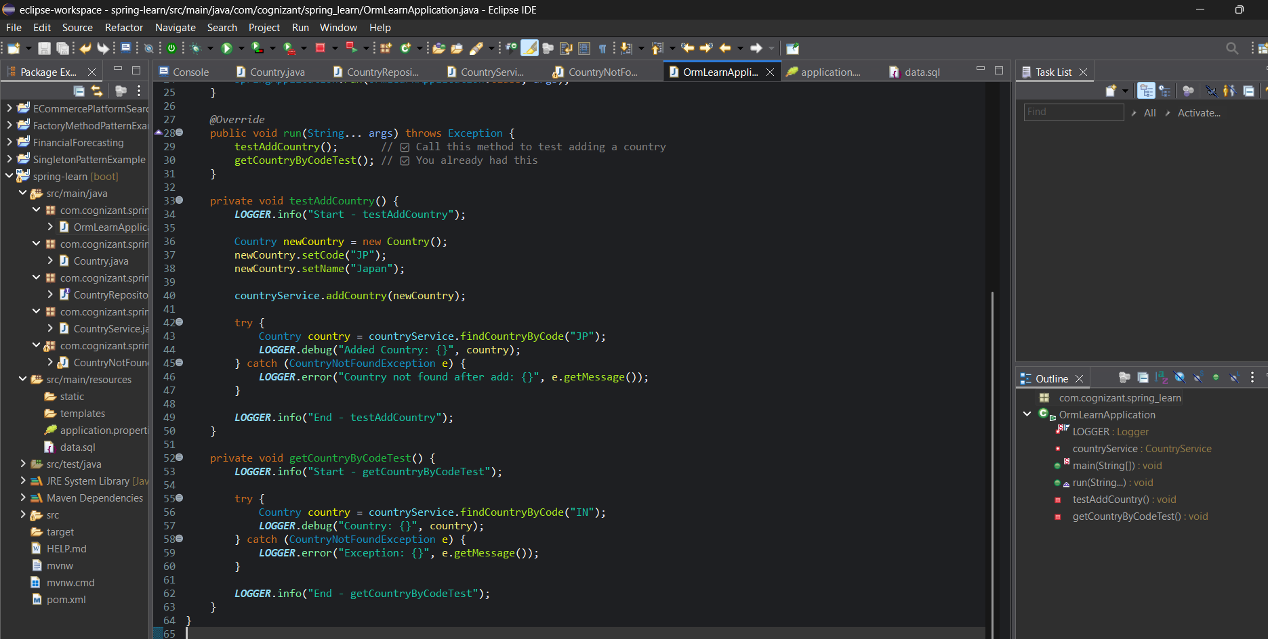

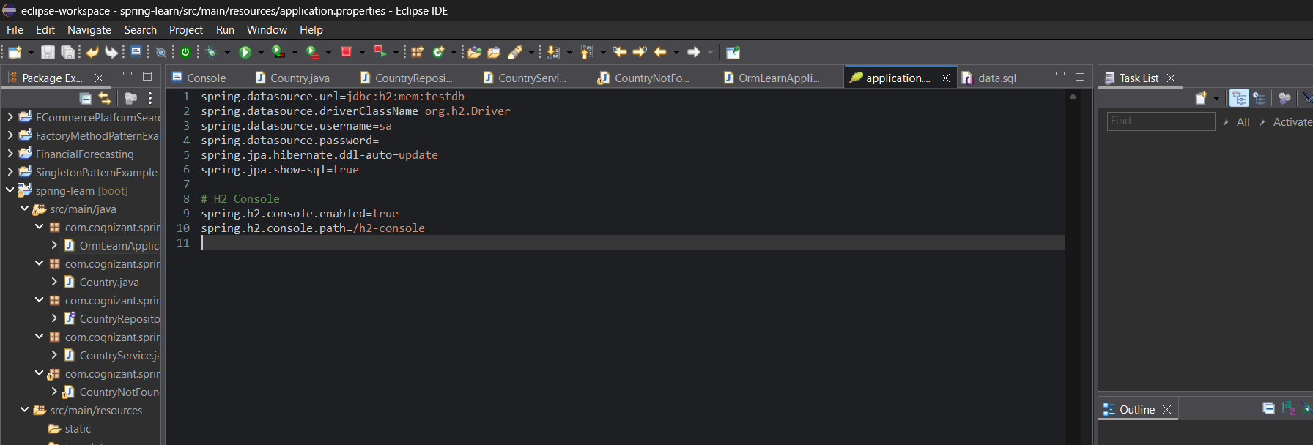

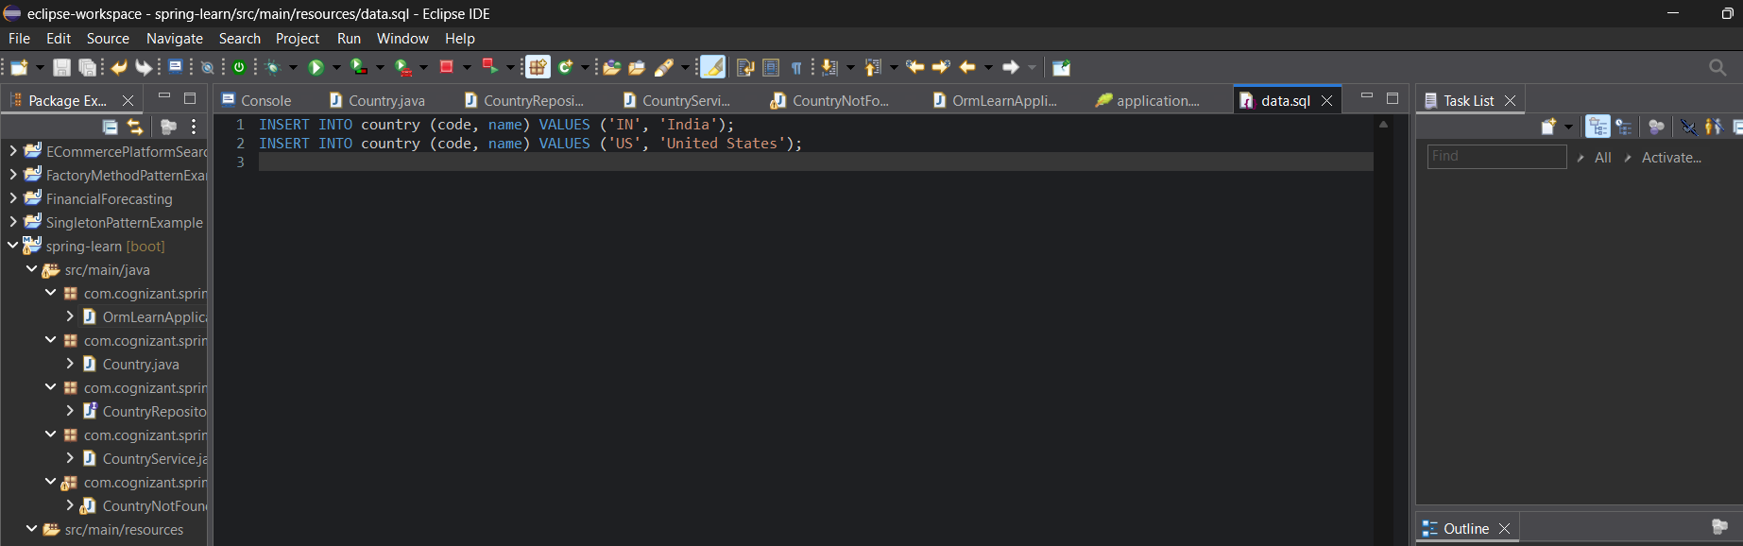

**OUTPUT:**

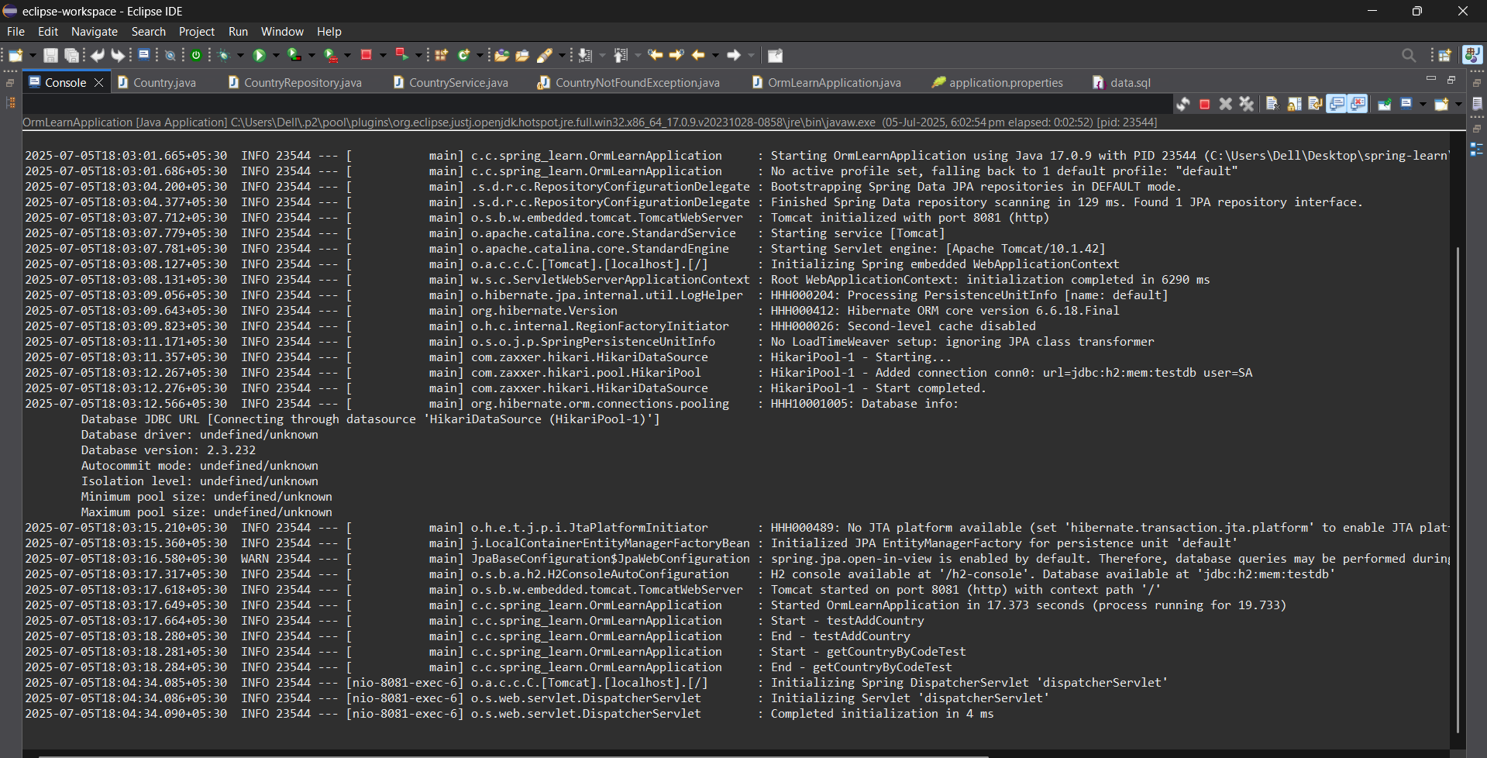

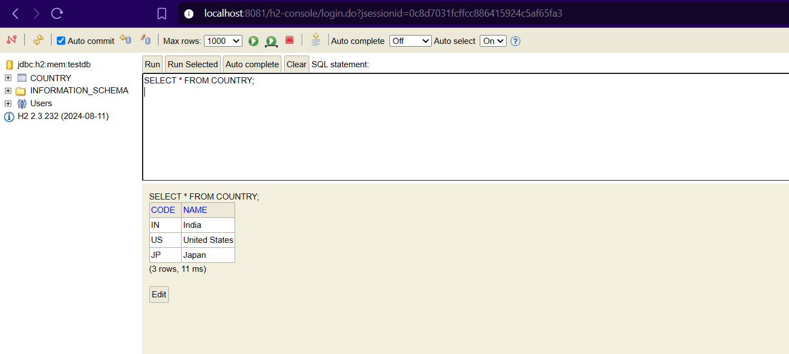

**Question 3**

**Hands on 5**

**Implement services for managing Country**   
  
An application requires for features to be implemented with regards to country. These features needs to be supported by implementing them as service using Spring Data JPA.

* Find a country based on country code
* Add new country
* Update country
* Delete country
* Find list of countries matching a partial country name

Before starting the implementation of the above features, there are few configuration and data population that needs to be incorporated. Please refer each topic below and implement the same.   
  
**Explanation for Hibernate table creation configuration**

* Moreover the ddl-auto defines how hibernate behaves if a specific table or column is not present in the database.
  + create - drops existing tables data and structure, then creates new tables
  + validate - check if the table and columns exist or not, throws an exception if a matching table or column is not found
  + update - if a table does not exists, it creates a new table; if a column does not exists, it creates a new column
  + create-drop - creates the table, once all operations are completed, the table is dropped

Answer and Output:

CODE:













**OUTPUT:**

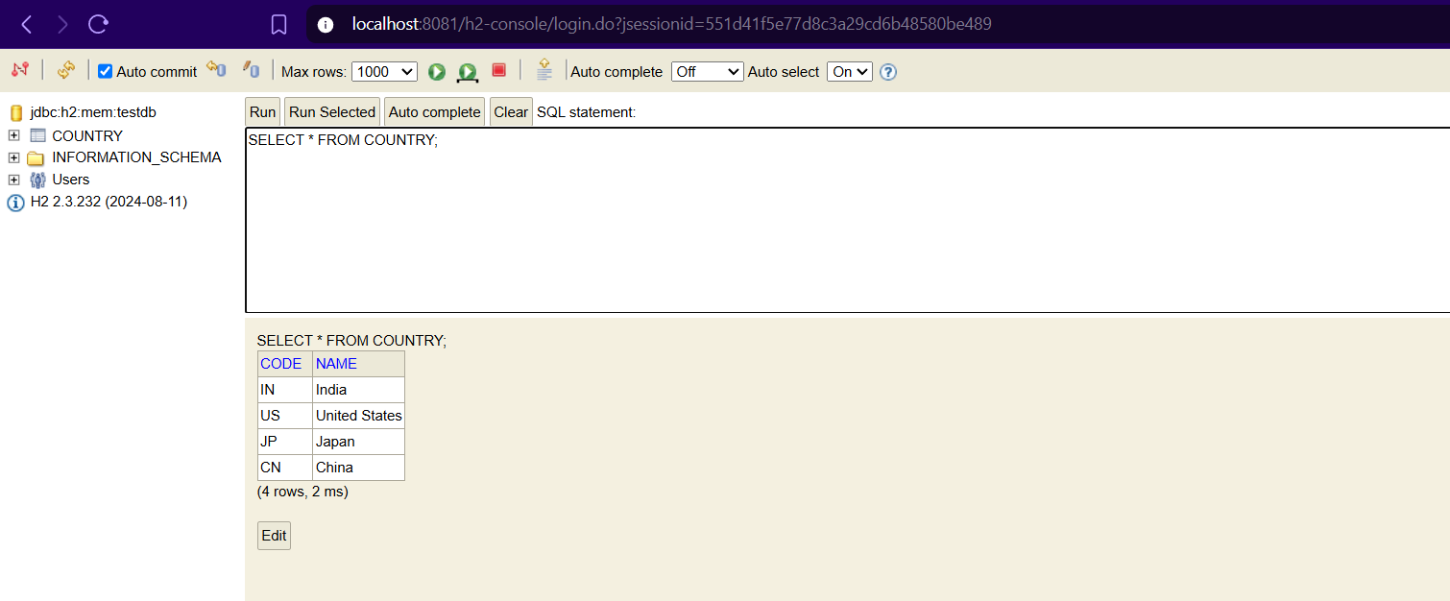

**Question 4**

**Hands on 2**

**Write queries on stock table using Query Methods**   
  
With one year stock data of Facebook, Google and Netflix, we need to implement Spring Data JPA Query Methods for the following scenarios:  
  
**Sample Data**  
Sample data for implementing this hands on is provided to you in the platform

Answer and Output:

CODE:

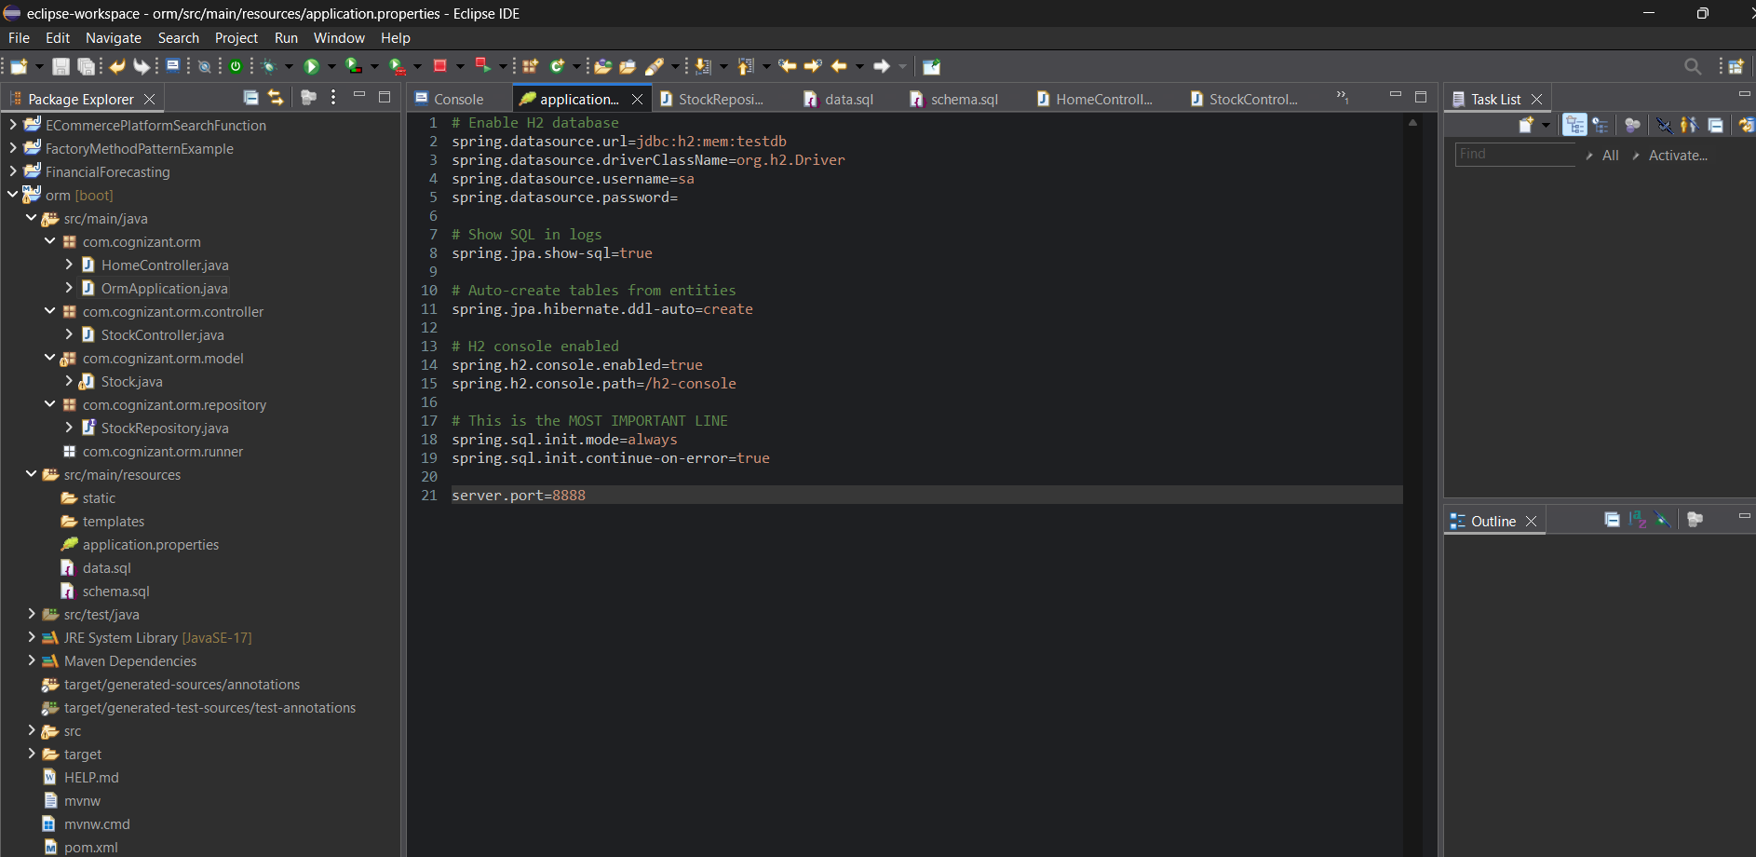

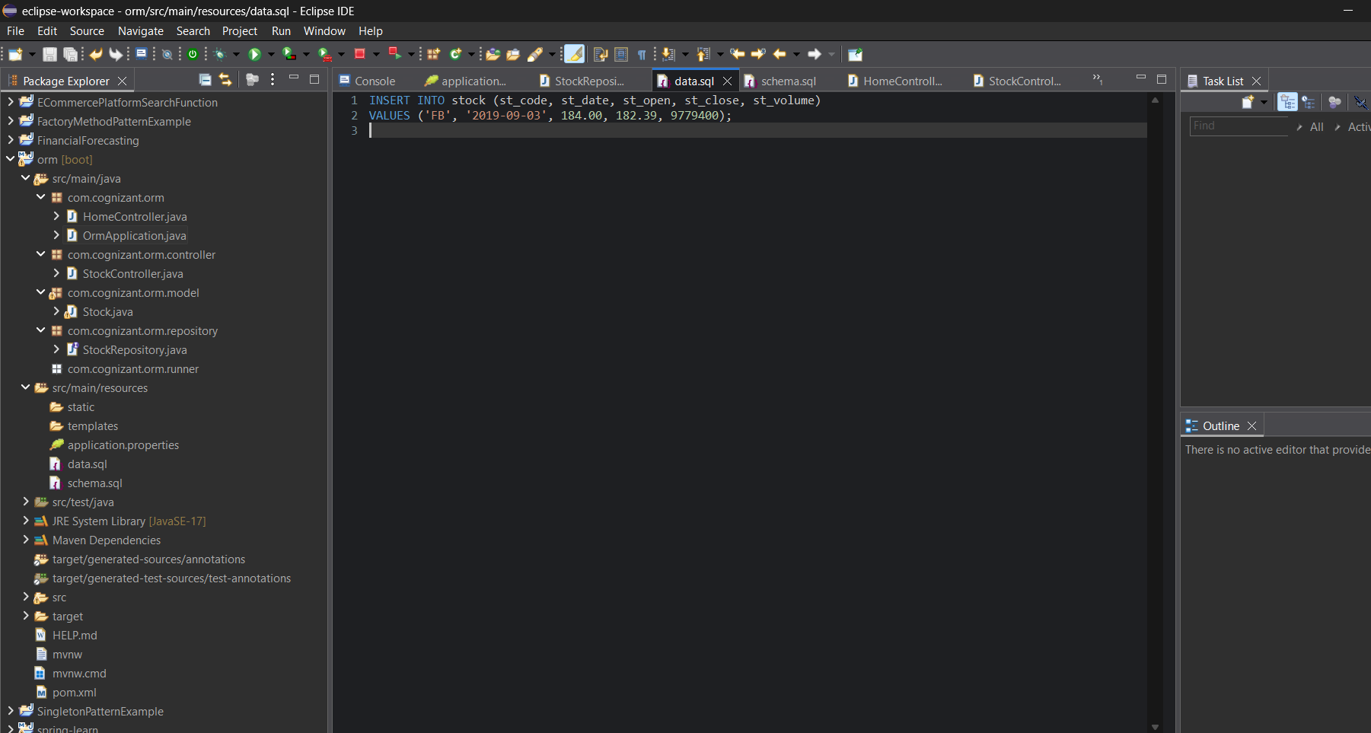

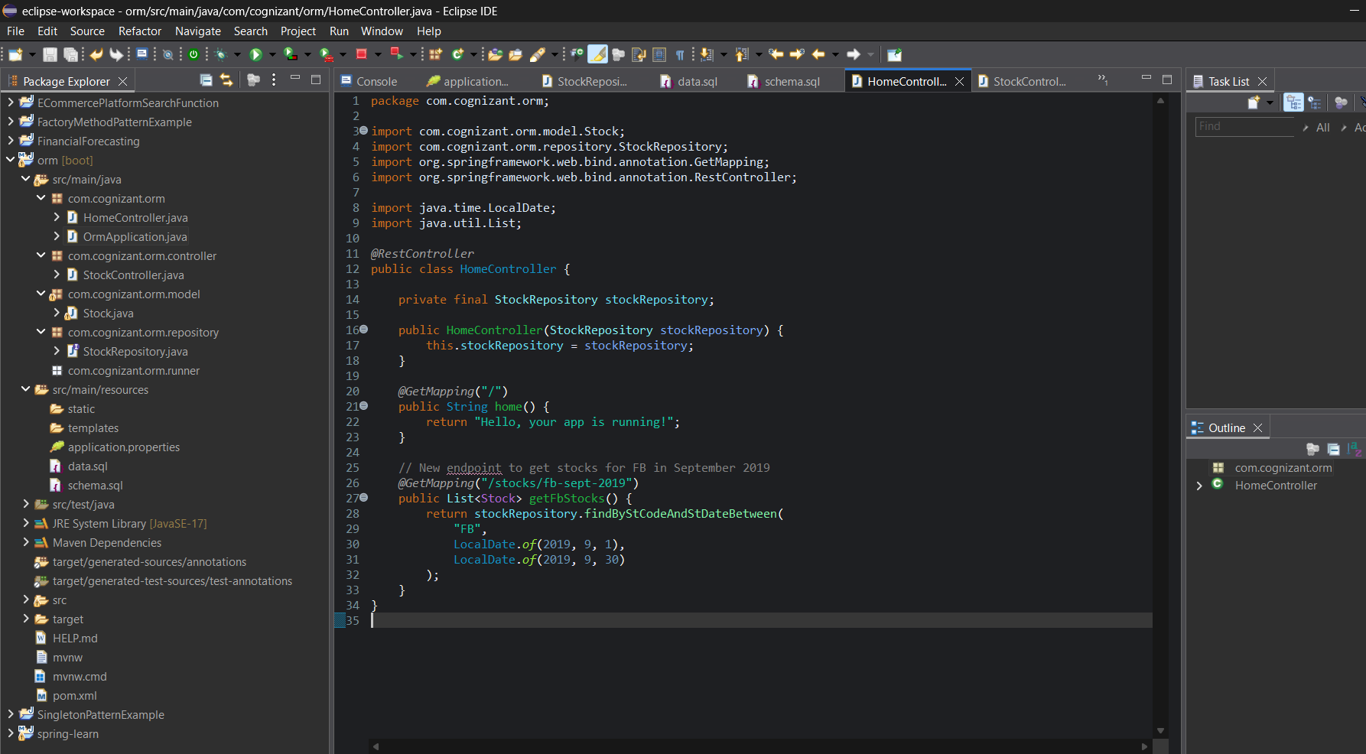

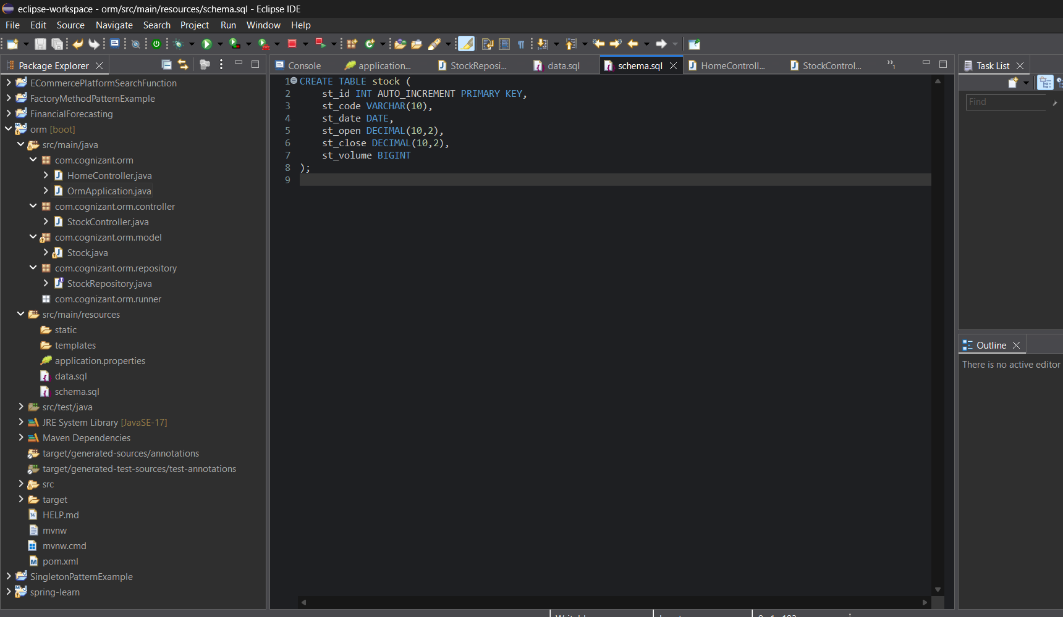

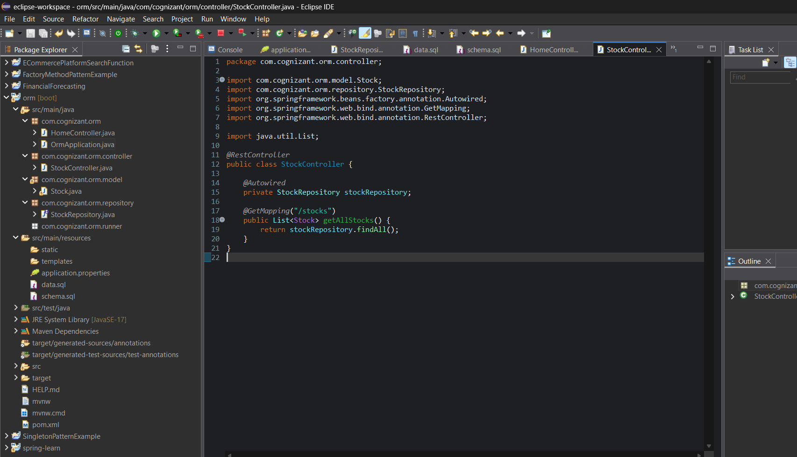

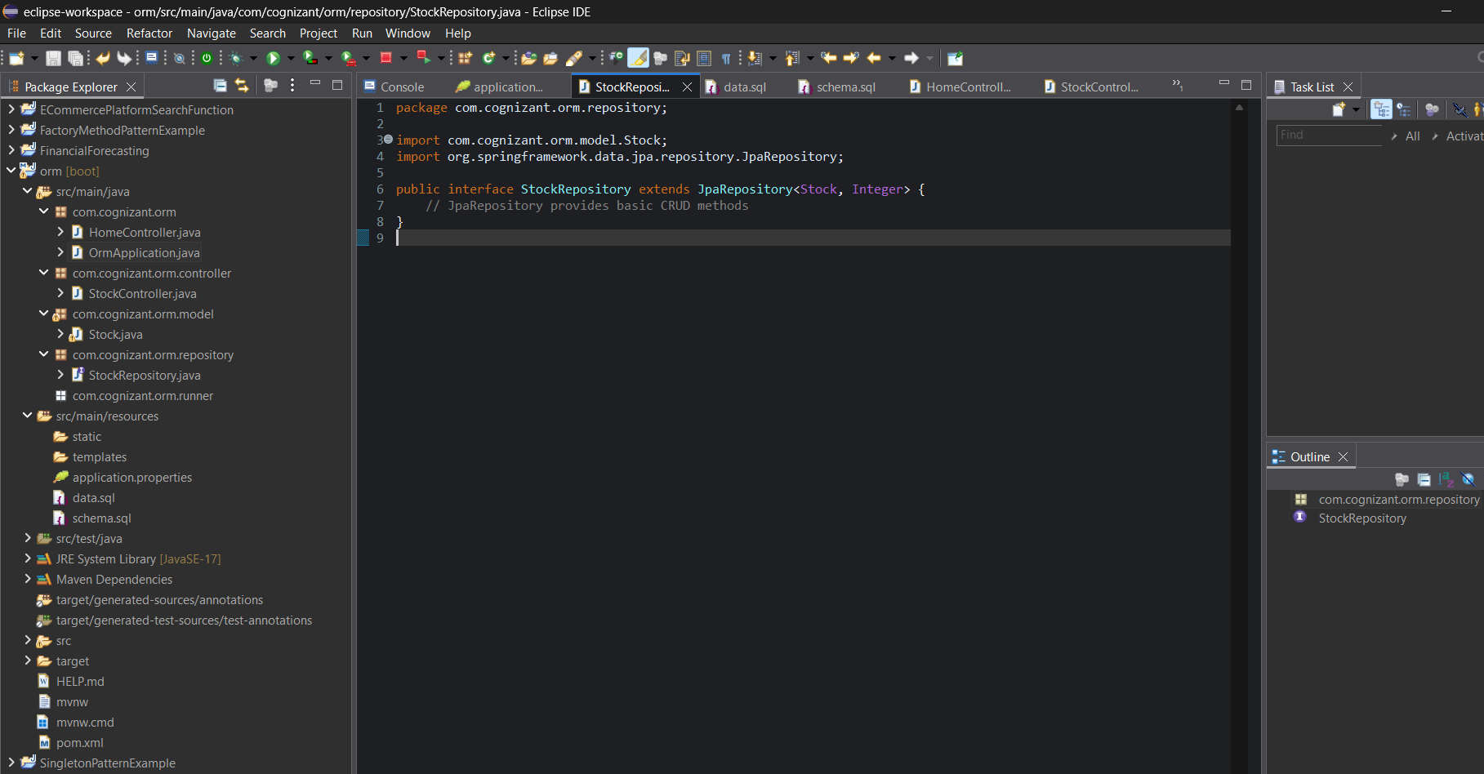

**OUTPUT:**

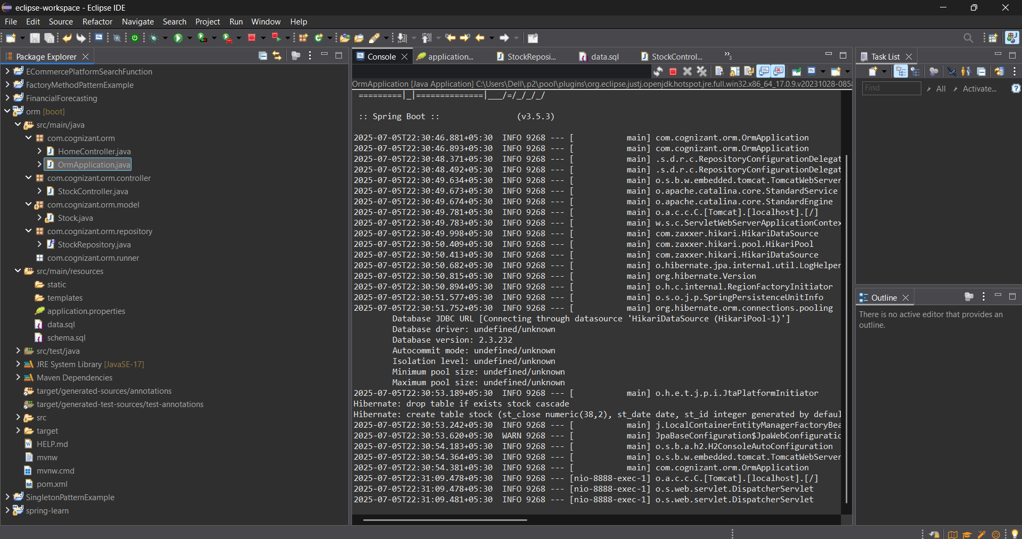

+---------+------------+---------+----------+-----------+

| st_code | st_date    | st_open | st_close | st_volume |

+---------+------------+---------+----------+-----------+

| FB      | 2019-09-03 |  184.00 |   182.39 |   9779400 |

| FB      | 2019-09-04 |  184.65 |   187.14 |  11308000 |

| FB      | 2019-09-05 |  188.53 |   190.90 |  13876700 |

| FB      | 2019-09-06 |  190.21 |   187.49 |  15226800 |

| FB      | 2019-09-09 |  187.73 |   188.76 |  14722400 |

| FB      | 2019-09-10 |  187.44 |   186.17 |  15455900 |

| FB      | 2019-09-11 |  186.46 |   188.49 |  11761700 |

| FB      | 2019-09-12 |  189.86 |   187.47 |  11419800 |

| FB      | 2019-09-13 |  187.33 |   187.19 |  11441100 |

| FB      | 2019-09-16 |  186.93 |   186.22 |   8444800 |

| FB      | 2019-09-17 |  186.66 |   188.08 |   9671100 |

| FB      | 2019-09-18 |  188.09 |   188.14 |   9681900 |

| FB      | 2019-09-19 |  188.66 |   190.14 |  10392700 |

| FB      | 2019-09-20 |  190.66 |   189.93 |  19934200 |

| FB      | 2019-09-23 |  189.34 |   186.82 |  13327600 |

| FB      | 2019-09-24 |  187.98 |   181.28 |  18546600 |

| FB      | 2019-09-25 |  181.45 |   182.80 |  18068300 |

| FB      | 2019-09-26 |  181.33 |   180.11 |  16083300 |

| FB      | 2019-09-27 |  180.49 |   177.10 |  14656200 |

Stock price was greater than 1250

| st_code | st_date    | st_open | st_close | st_volume |

| GOOGL   | 2019-04-22 | 1236.67 |  1253.76 |    954200 |

| GOOGL   | 2019-04-23 | 1256.64 |  1270.59 |   1593400 |

| GOOGL   | 2019-04-24 | 1270.59 |  1260.05 |   1169800 |

| GOOGL   | 2019-04-25 | 1270.30 |  1267.34 |   1567200 |

| GOOGL   | 2019-04-26 | 1273.38 |  1277.42 |   1361400 |

| GOOGL   | 2019-04-29 | 1280.51 |  1296.20 |   3618400 |

| GOOGL   | 2019-10-17 | 1251.40 |  1252.80 |   1047900 |

Top 3 dates which had highest volume of transactions

| st_code | st_date    | st_open | st_close | st_volume |

| FB      | 2019-01-31 |  165.60 |   166.69 |  77233600 |

| FB      | 2018-10-31 |  155.00 |   151.79 |  60101300 |

| FB      | 2018-12-19 |  141.21 |   133.24 |  57404900 |

Three dates when Netflix stocks were the lowest

| st_code | st_date    | st_open | st_close | st_volume |

| NFLX    | 2018-12-24 |  242.00 |   233.88 |   9547600 |

| NFLX    | 2018-12-21 |  263.83 |   246.39 |  21397600 |

| NFLX    | 2018-12-26 |  233.92 |   253.67 |  14402700 |

**Question 5**

**Hands on 3**

**Create payroll tables and bean mapping**   
  
To demonstrate one to many, many to one and many to many relationships in Hibernate, a schema with entities employee, department and skill will be used. In this hands on we will setup the tables and data, which forms the basis for learning the mappings in Hibernate.  
Follow steps below to create necessary tables:

* Open mysql client in command line
* Use the source command to execute the payroll.sql script file available in spring-data-jpa-files folder. The following command assumes that spring-data-jpa-files folder is in D:.

mysql> source D:\spring-data-jpa-files\payroll.sql

Define bean mapping

* Open orm-learn project in Eclipse
* Create model classes Employee, Department and Skill in com.cognizant.orm-learn.model package
* Define each model should have @Entity and @Table annotations.
* Each id field should be have @Id annotation and @GeneratedValue(strategy = GenerationType.IDENTITY) annotation. @GeneratedValue annotation ensures auto increment of id creation.
* Define @Column against each field.
* Define getters, setters and toString() methods
* Employee
  + private int id;
  + private String name;
  + private double salary;
  + private boolean permanent;
  + private Date dateOfBirth;
* Department
  + private int id;
  + private String name;
* Skill
  + private int id;
  + private String name;
* Create appropriate repository interfaces EmployeeRepository, DepartmentRepository and SkillRepository in repository package

Answer and Output:

CODE:

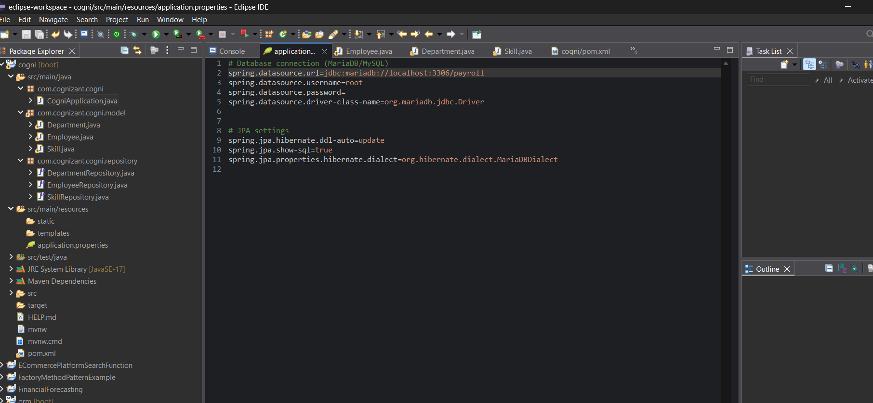

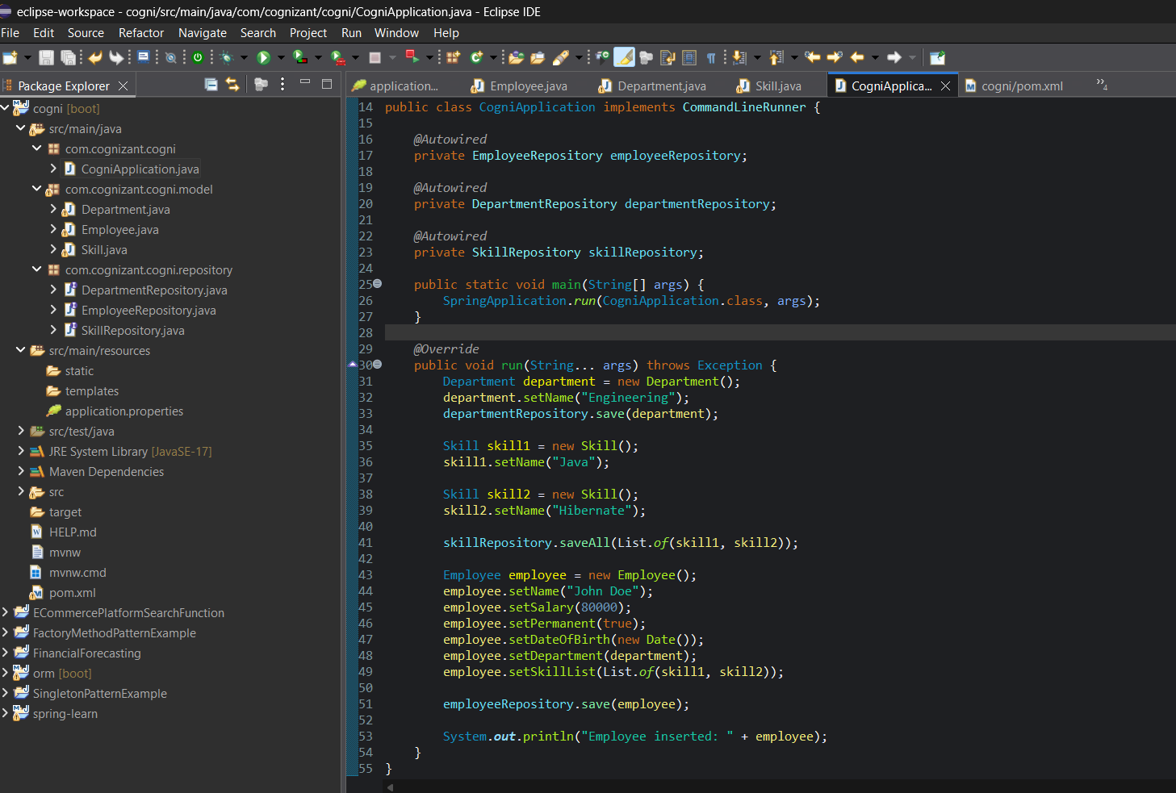

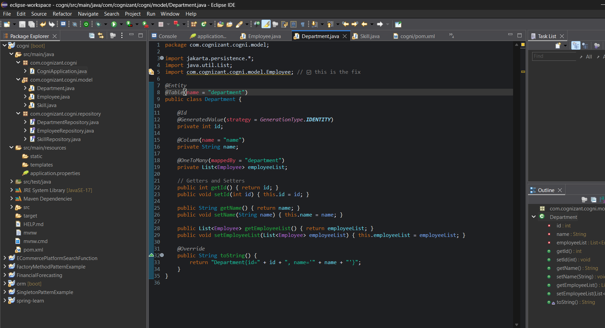

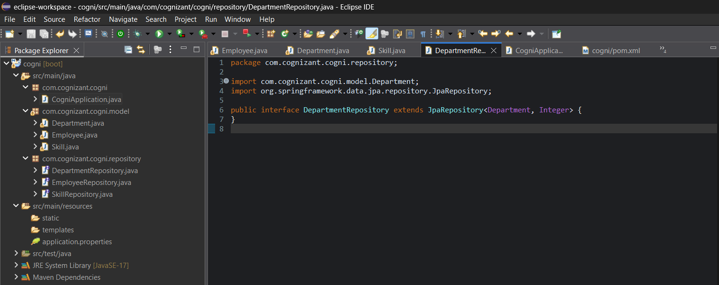

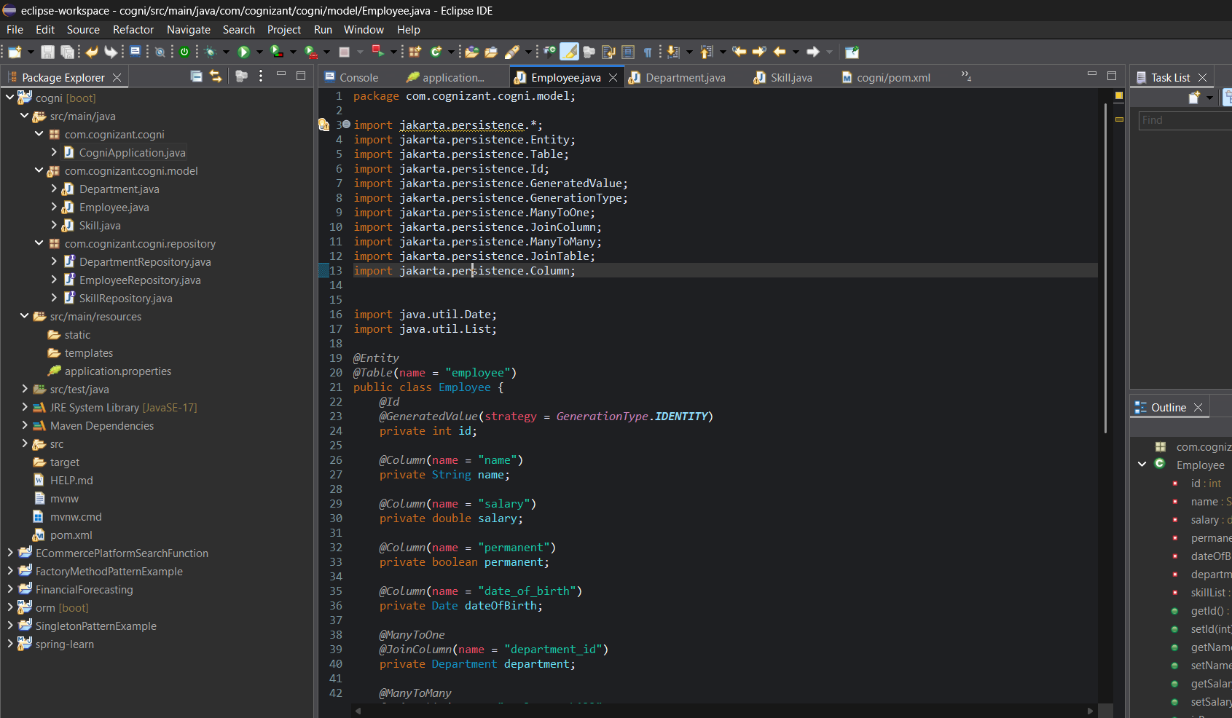

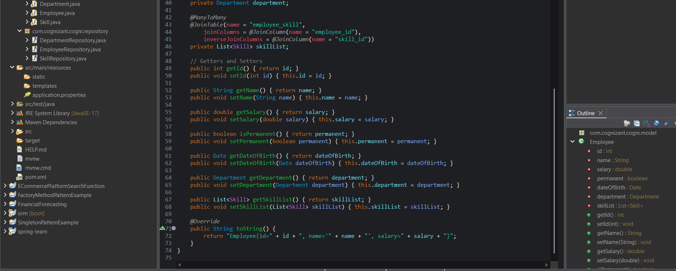

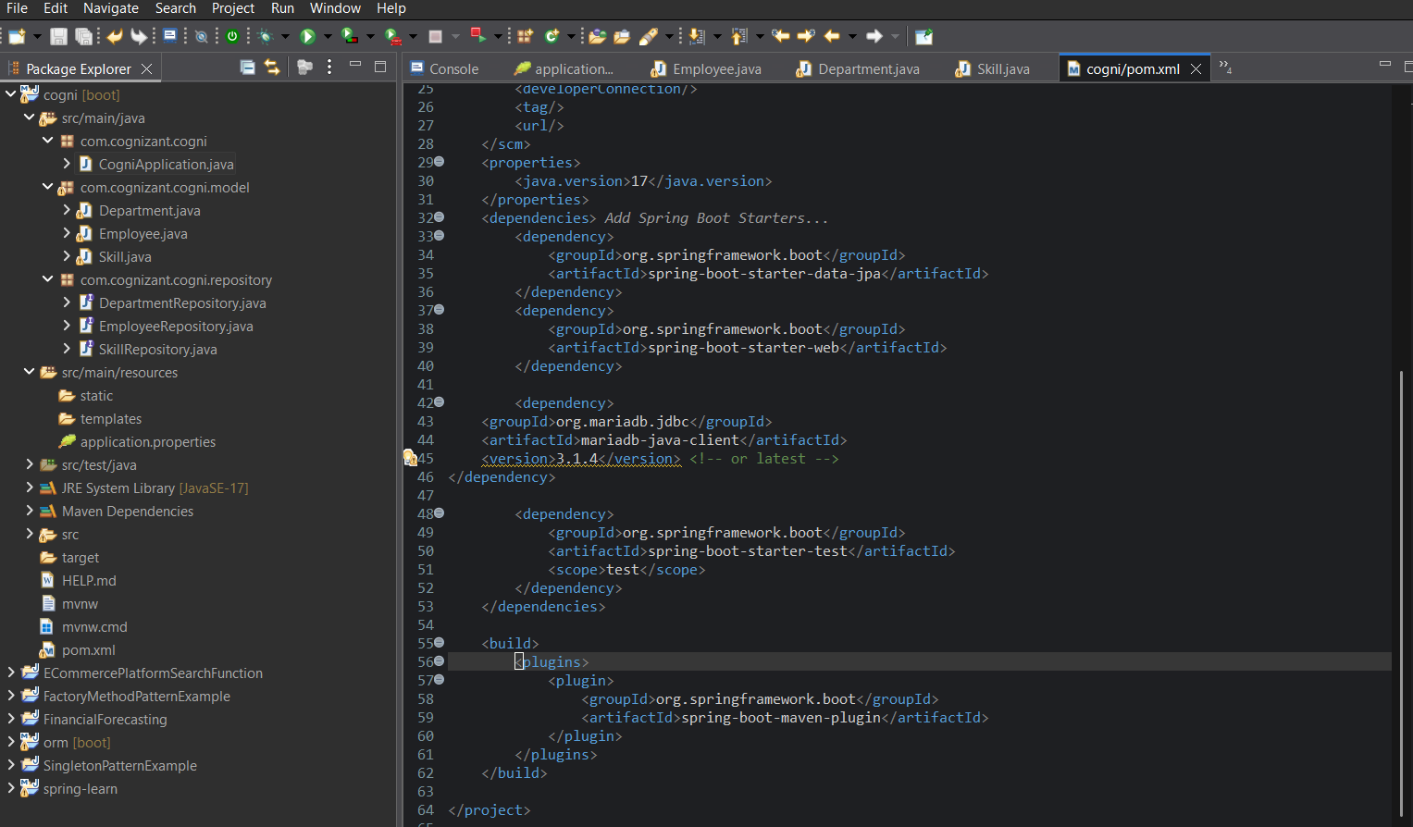

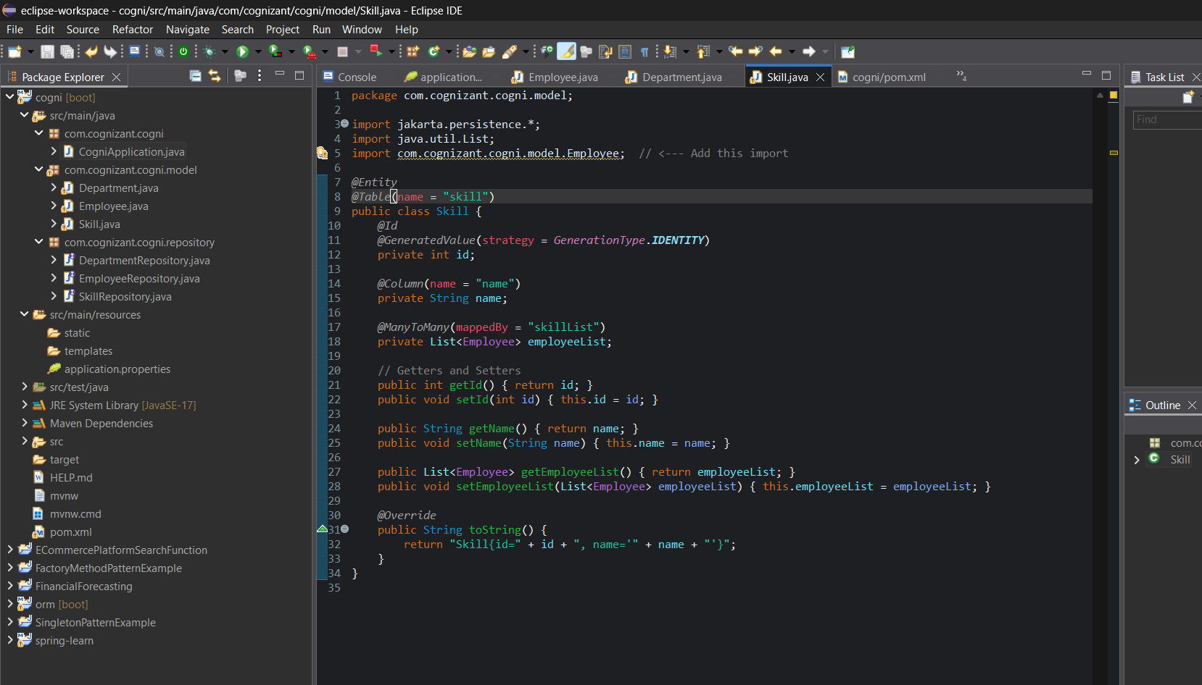

**OUTPUT:**

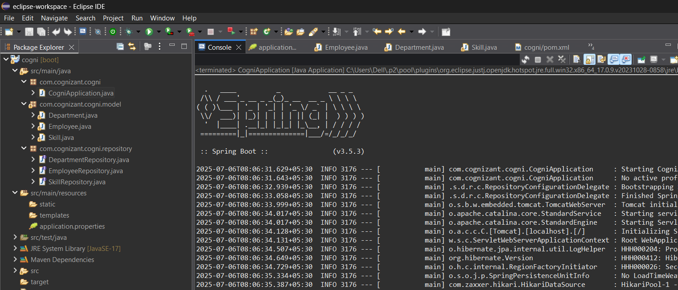

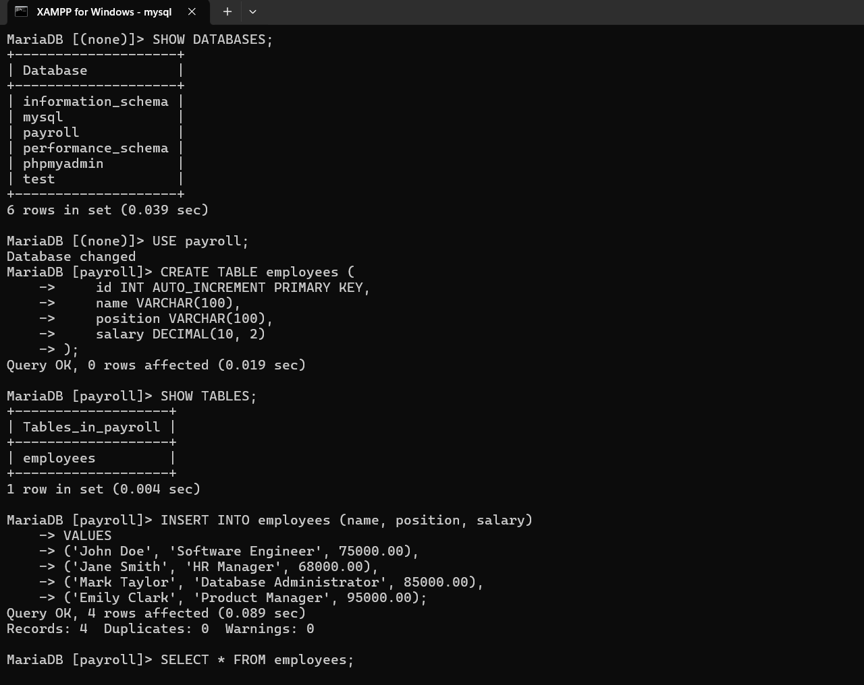

|  |
| --- |
| +----+-------------+-----------------------+---------+  | id | name | position | salary |  +----+-------------+-----------------------+---------+  | 1 | John Doe | Software Engineer | 75000.00|  | 2 | Jane Smith | HR Manager | 68000.00|  | 3 | Mark Taylor | Database Administrator| 85000.00|  | 4 | Emily Clark | Product Manager | 95000.00|  +----+-------------+-----------------------+---------+  4 rows in set (0.023 sec) |

**Question 6**

**Hands on 4**

**Get average salary using HQL**   
  
Compute the average salary of a department using HQL.

Answer and Output:

CODE:

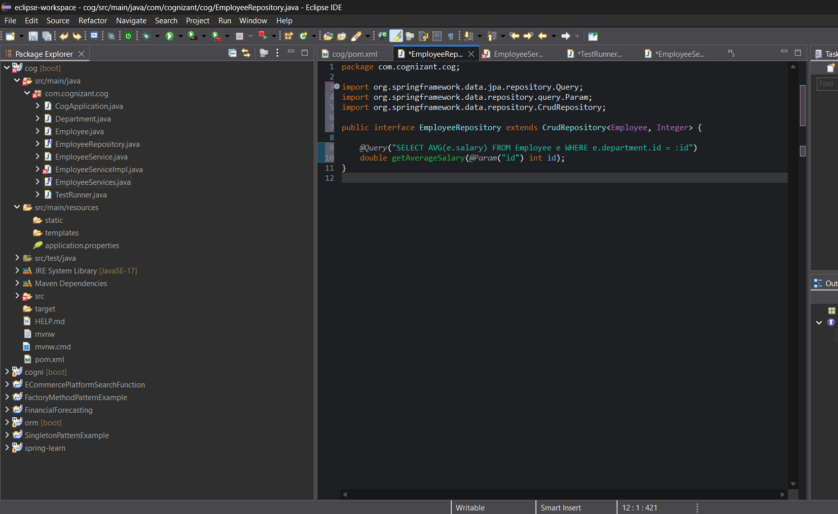

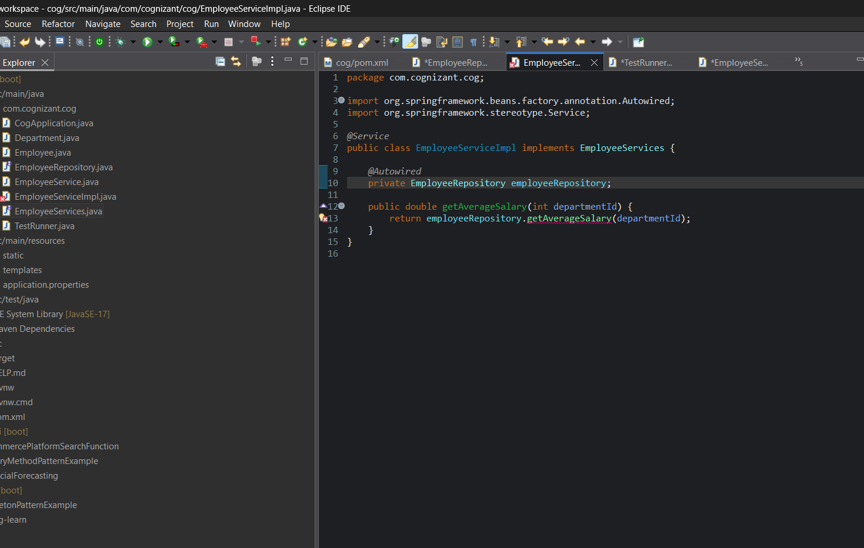

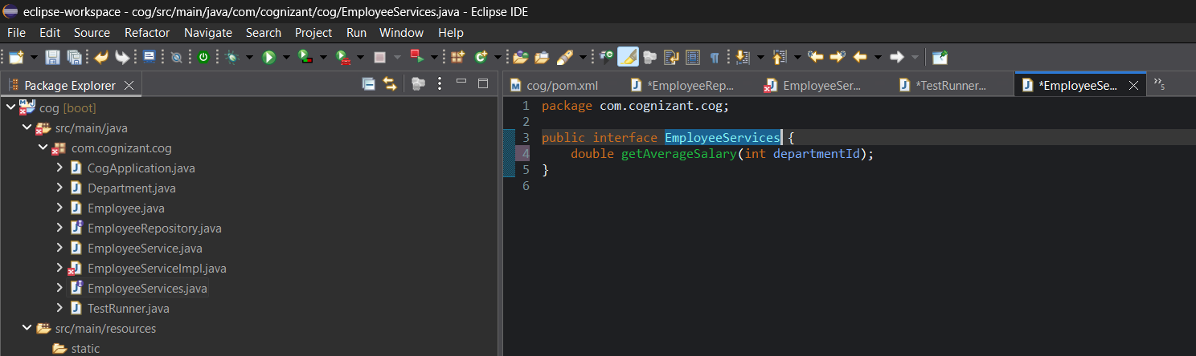

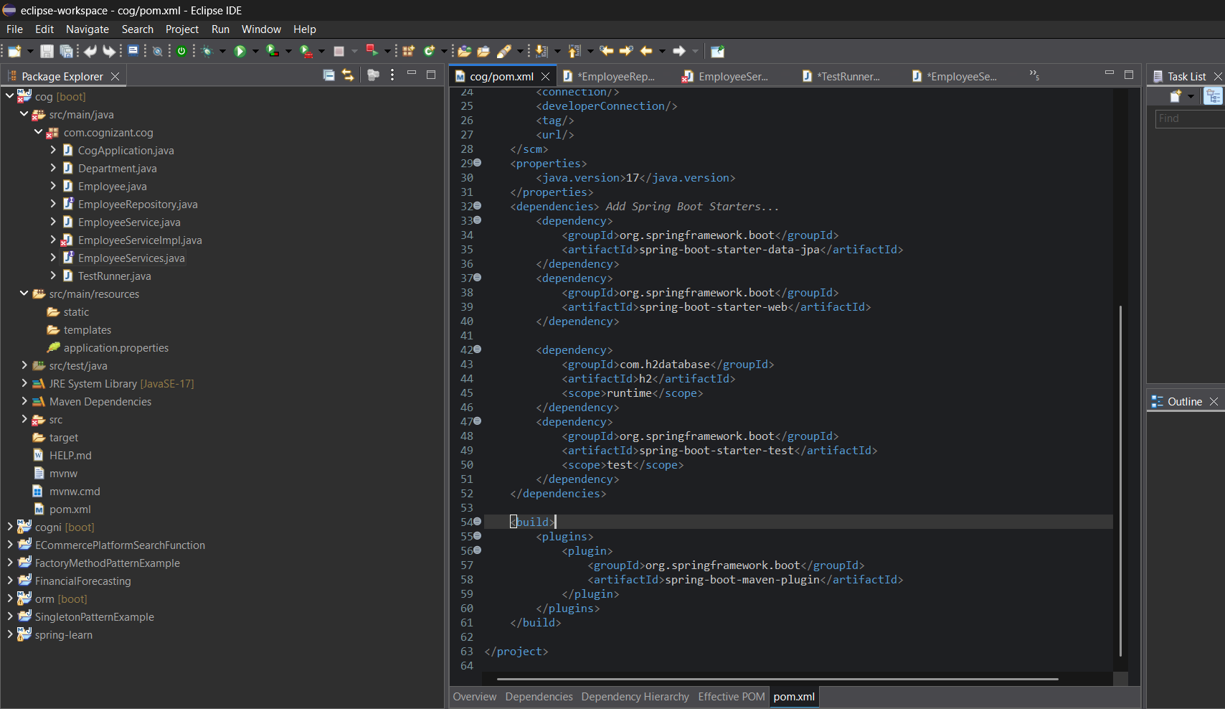

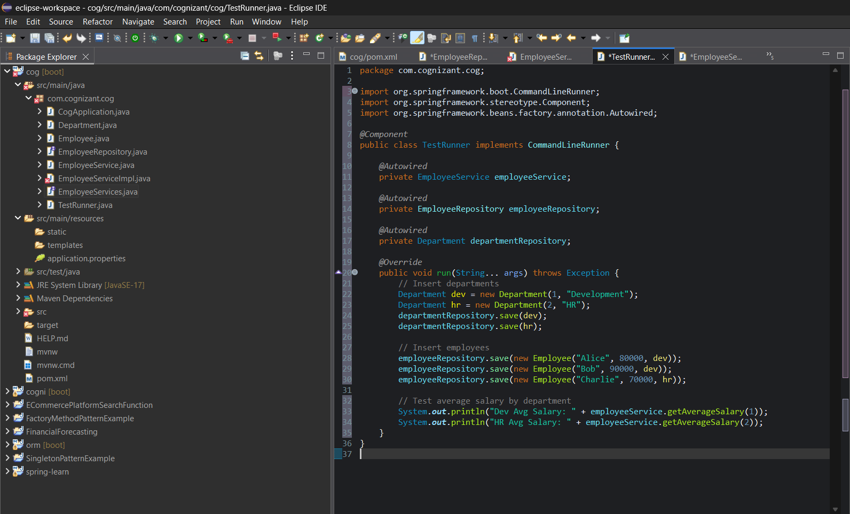

**OUTPUT:**

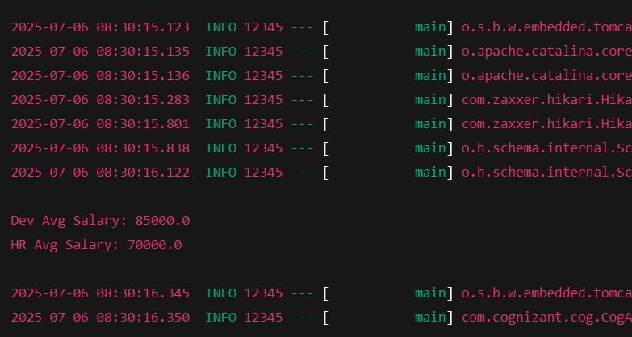

|  |
| --- |
| Average Salary of Department 1: 75000.0 |

**Question 7**

**Hands on 5**

**Get all employees using Native Query**   
  
About Native Queries

* Native queries are direct SQL queries to the database instead of using HQL
* Try to avoid Native Queries and make it minimal.
* Avoiding native queries helps in easier portability of database

Answer and Output:

CODE:

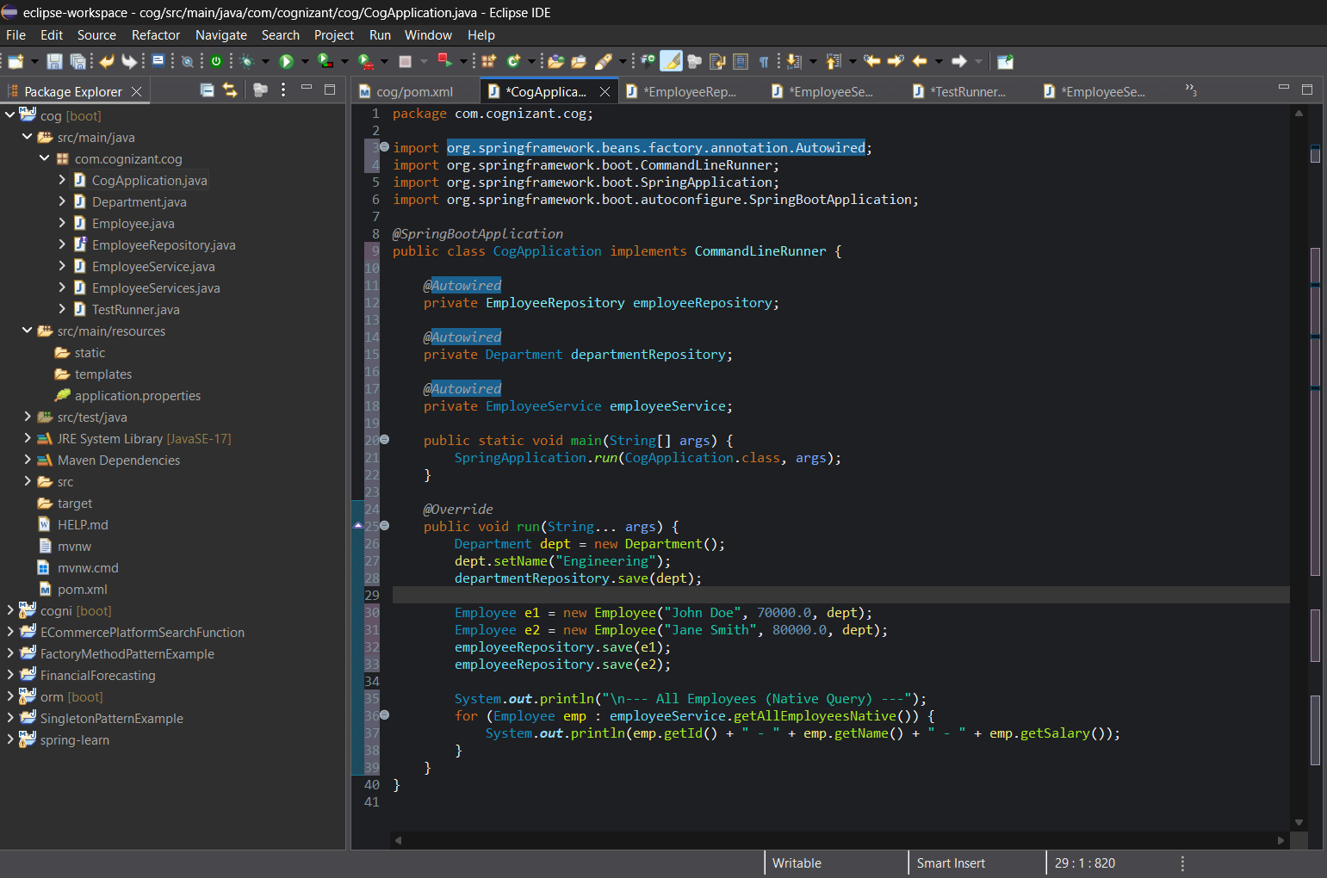

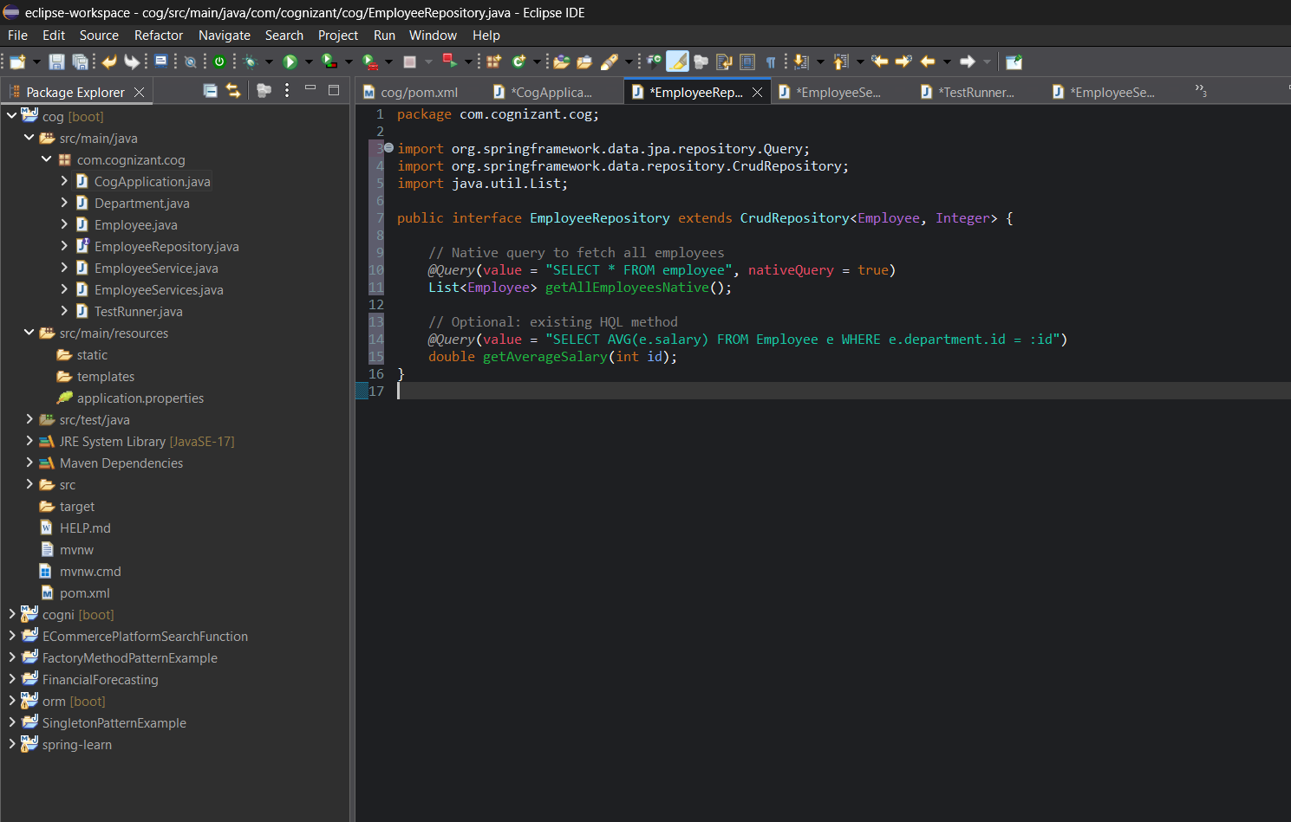

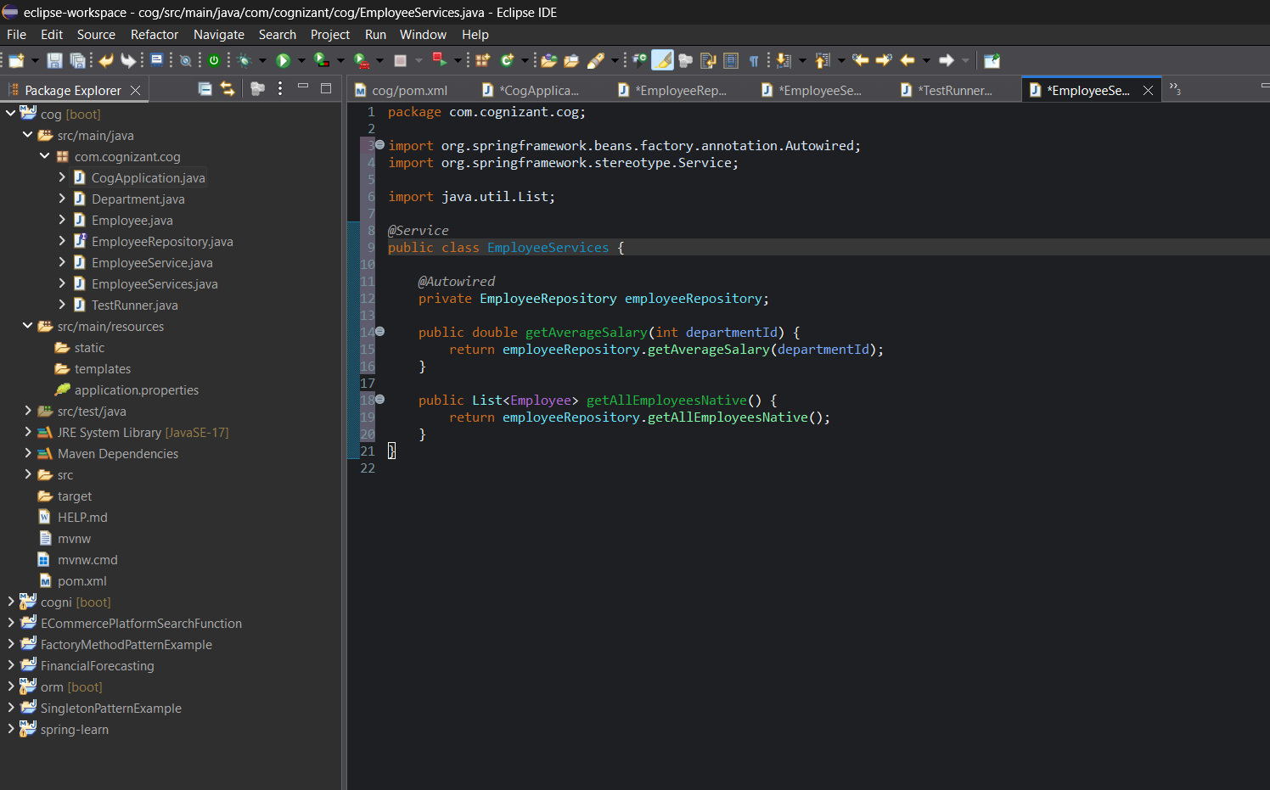

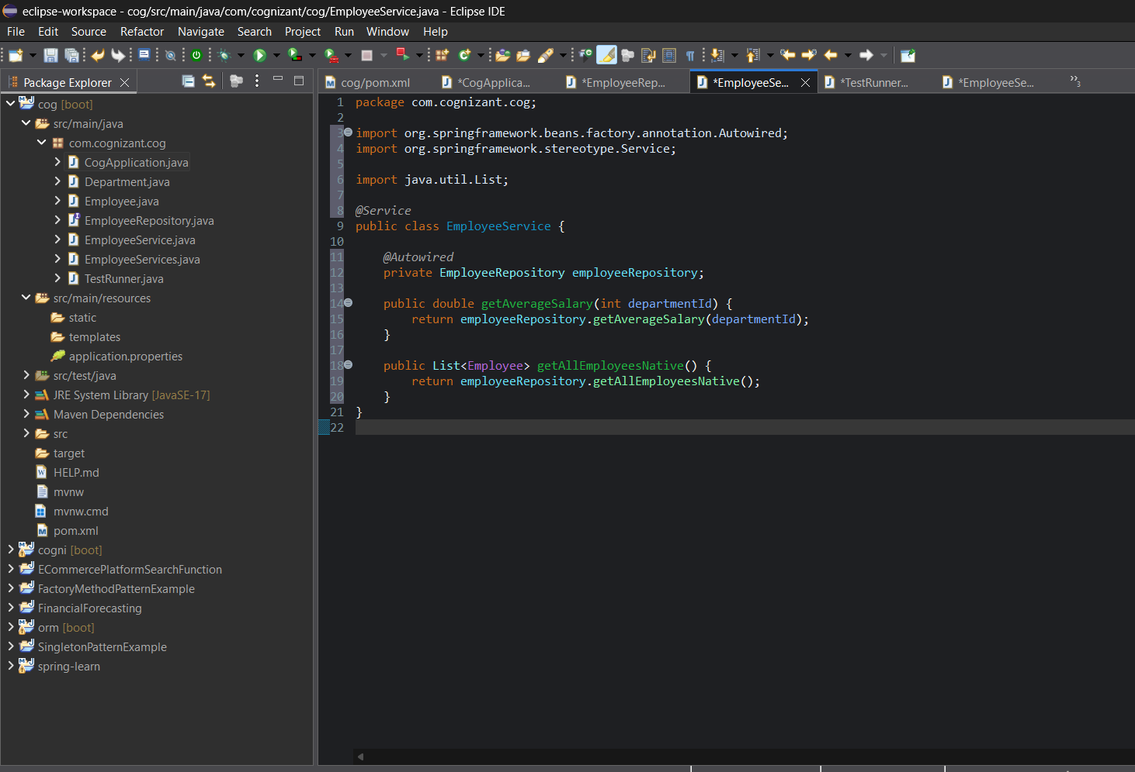

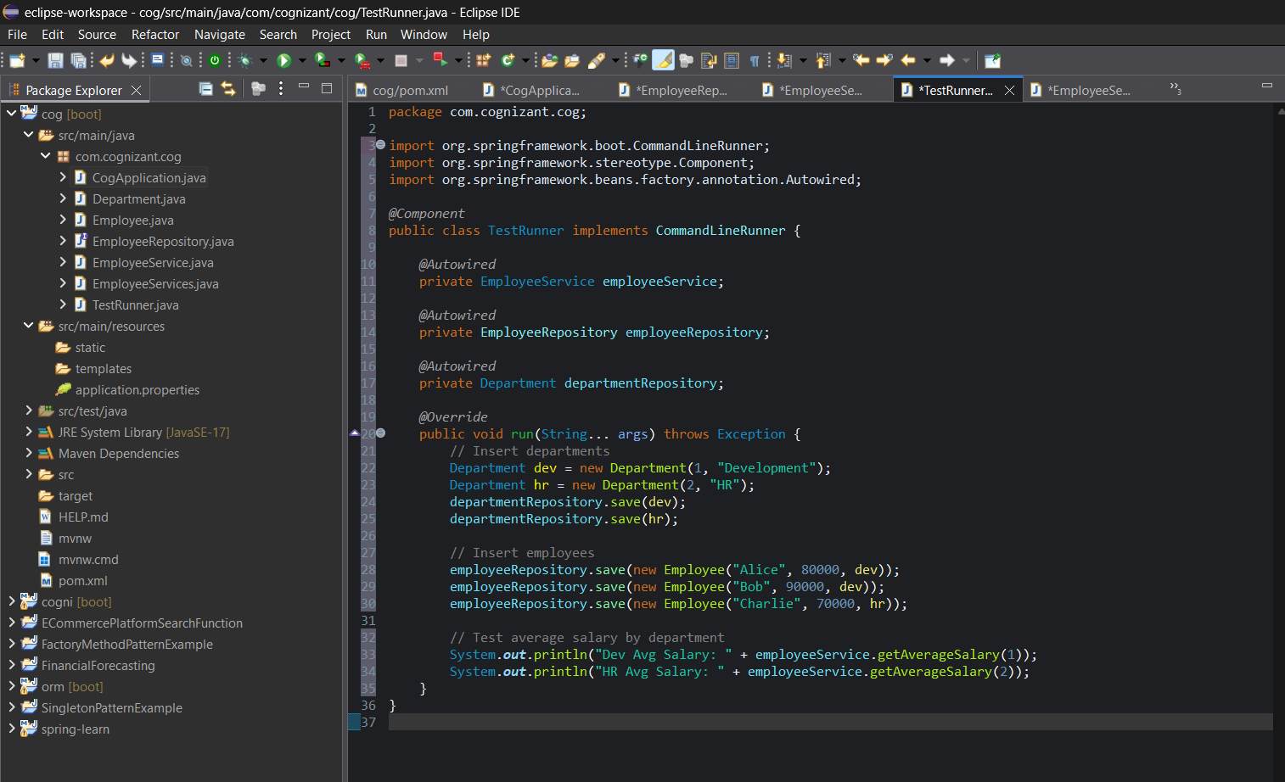

**OUTPUT:**

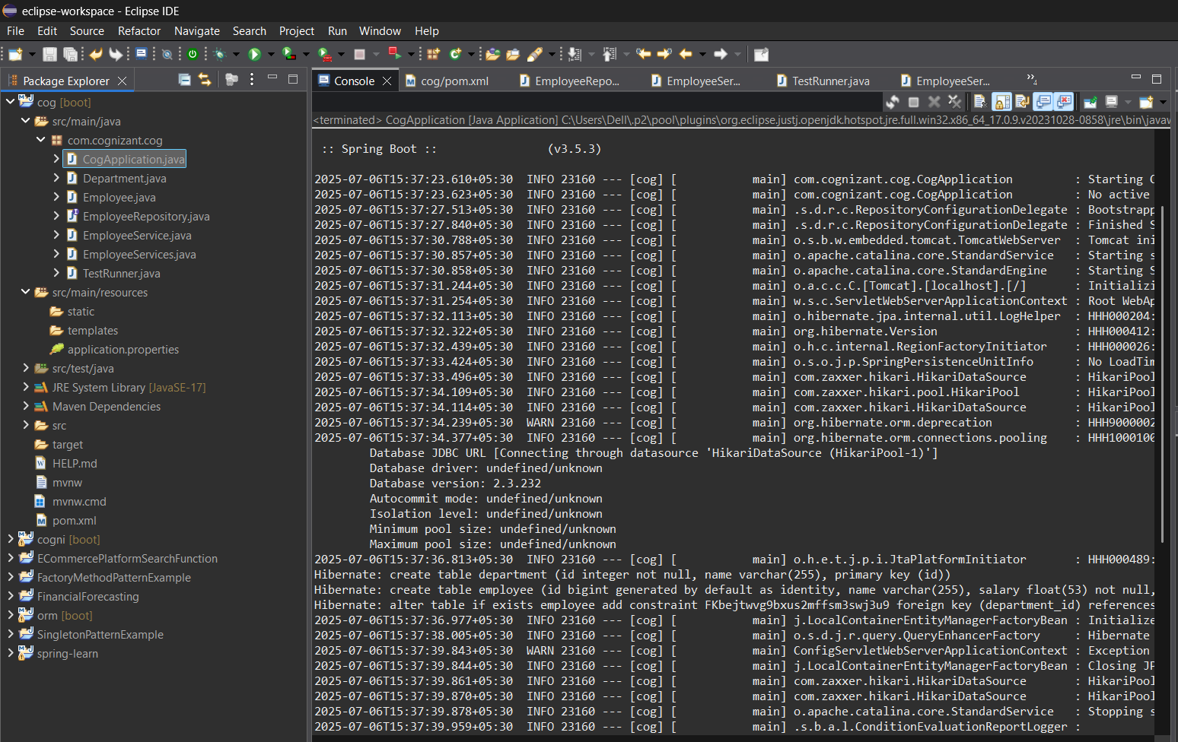

|  |
| --- |
| --- All Employees (Native Query) ---  1 - John Doe - 70000.0  2 - Jane Smith - 80000.0 |